10C Unit 2: Trigonometry Practice Booklet
2.1 Trigonometric Ratios
- Consider the three triangles below. For each triangle, complete the table for the angle xº.
Triangle | Opposite Side | Adjacent Side | Hypotenuse | Sine Ratio | Cosine Ratio | Tangent Ratio
A)

B)

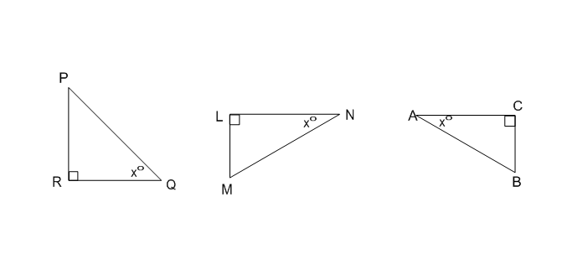
C)

A) B) C)

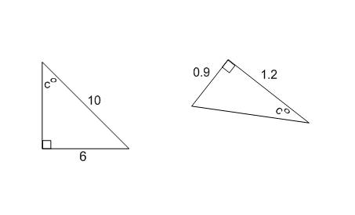
- Determine, as a fraction in simplest form, the values of the three trigonometric ratios.
- Sin c = B) Sin c =

Cos c = Cos c =

Tan c = Tan c =

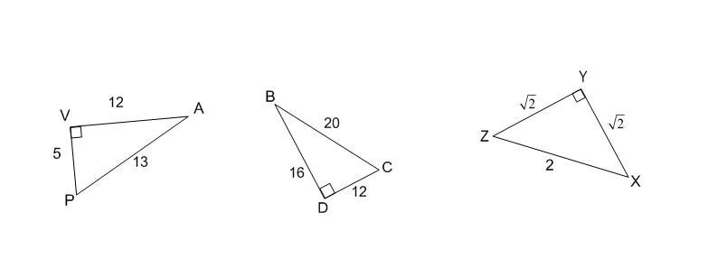
- In each case, write the rational number which represents the trigonometric ratio.
A) Sin A = B) cos B = C) tan X =

- In right triangle ABC, AB = 52 units, AC = 48 units and BC = 20 units. The value of cos B and sin B are respectively
- $\frac{5}{13}$ and $\frac{12}{13}$
- $\frac{12}{13}$ and $\frac{5}{13}$
- $\frac{5}{12}$ and $\frac{12}{5}$
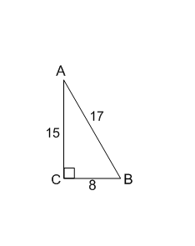
- $\frac{5}{13}$ and $\frac{12}{5}$

- For the right angled triangle ABC, only one of the following ratios is correct. The correct ratio is
- $\sin{A= \frac{8}{15}}$
- $\cos{A= \frac{8}{17}}$
- $\tan{B= \frac{8}{15}}$
- $\sin{B= \frac{15}{17}}$

- In a right triangle $\tan{x°}= \frac{7}{5}$. A student claims this indicated that in the right triangle the side opposite to the angle $x°=7$ and the side adjacent to the angle $x°=5.$ The student’s claim
- is always true
- is always false
- may be true or false
- depends on the value of $x°$

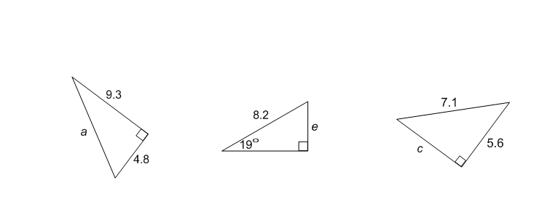
2.2 Calculating the Side Length in a Right Triangle
1. Calculate, to the nearest tenth, the length of the indicated side in each triangle.
- B) C)

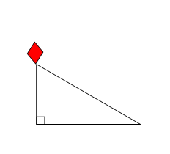

2. The kite string is 65 metres long and makes an angle of 32º with the ground. Calculate, to the nearest metre, the vertical height, h, of the middle of the kite above the ground.

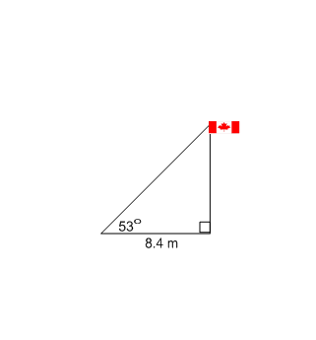

3. Use the measurements in the diagram to determine the height of the flagpole to the nearest tenth of a metre.

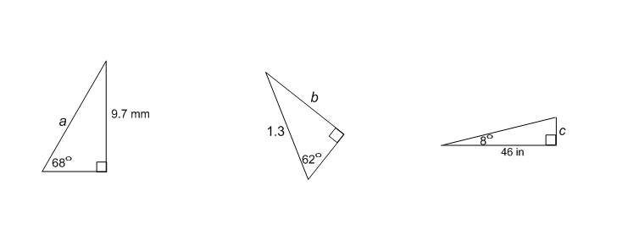

4. Calculate, to the nearest tenth, the length of the indicated side in each triangle.
A) B) C)

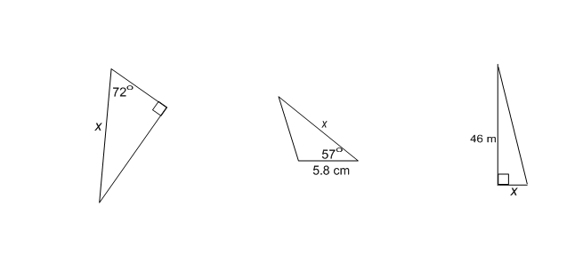
5. Explain why trigonometric ratios could not be used to calculate the side marked x in each of the following triangles.
A) B) C)

6. Triangle DEF is right angled at F. Angle DEF = 36º and DF = 15 cm. The length of DE, in cm, is given by
- $15sin 36°$
- $\frac{15}{\cos{36°}}$
- $15\cos{54°}$
- $\frac{15}{\cos{54°}}$
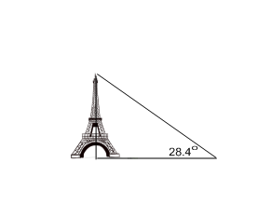

7. On a particular day, the Eiffel Tower in Paris casts a shadow of 599 m. Use the sketch to determine the height of the tower. To the nearest metre, the height of the tower is

Record your answer in the numerical response box.

8. In right triangle ABC, angle ABC = 90º angle BAC = 70º and AC = 29 units. To the nearest whole number, the perimeter of the triangle is _______.

Record your answer in the numerical response box.

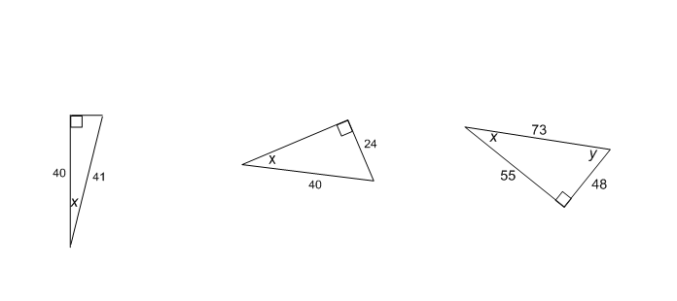
2.3 Calculating an Angle in a Right Angle Triangle
1. In each case, calculate the measure of the indicated angle to the nearest degree.
A) B) C)

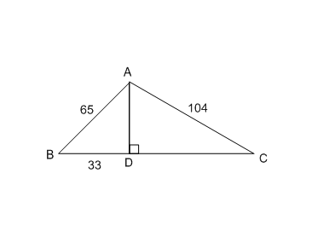

2. Consider the diagram consisting of two right triangles with a common side AD.
A) Find the length of AD

B) Determine, to the nearest degree, the measure of angle BCA.

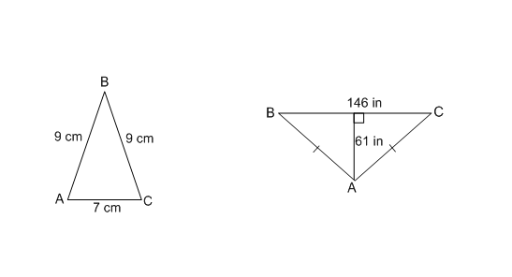

3. In each case calculate the size of <BAC to the nearest degree.
A) B)

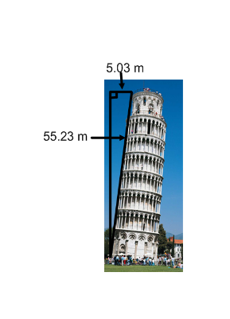
4. The Leaning Tower of Pisa is a building in Italy which leans due to the instability
of the ground underneath it. At different points in history the tower has leaned at
different angles. Use the measurements in the sketch to determine the angle of lean
from the vertical to the nearest hundredth of a degree.

5. A set of stairs has a vertical rise of 15 cm for every 28 cm horizontal run. To the nearest degree, the angle between the stairs and the floor is
A. 28º
B. 32º
C. 62º
D. 64º

6. A tourist at the top of a lighthouse spots a boat in the water below. The angle of depression of the boast from the tourist is 35º. At the same moment in time, the angle of elevation of the tourist from the boat, to the nearest degree, is _____.

Record your answer in the numerical response box.

7. A corner flag in a World Cup soccer match is 5 feet high. At game time, the flag casts a shadow which is 3.2 feet long. To the nearest 0.1 degree, the angle of elevation of the sun is _____.

Record your answer in the numerical response box.

8. A submarine goes into a dive at a certain angle of depression and travels 275 m while making its dive. When the submarine stops its dive it has dropped a vertical distance of 150 m. To the nearest tenth of a degree, the angle of depression of the dive is _____.

Record your answer in the numerical response box.

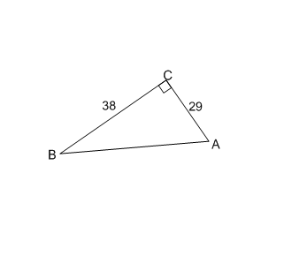
2.4 Application of Trigonometry

- Solve triangle ABC giving each measure correct to the nearest whole number.

- Solve triangle DEF in which angle DEF = 90º, angle EDF = 50º and DF = 173 mm. Give all answers to the nearest whole number.

- A boat is 300 m away from the foot of a cliff. The angle of elevation from the boat to the top of the cliff is 16º.
A) Show this information on a diagram and determine the height of the cliff to the nearest metre.

B) If the boat sails 75 m closer to the cliff, determine, to the nearest degree, the new angle of elevation of the cliff top from the boat.

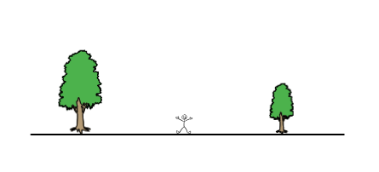
- Two trees in a park are 14.80 metres apart. An observer, whose eyeline is 1.80 m above the ground, is standing halfway between the trees. The angles of elevation of the tops of the trees from the observers eyeline are 17º and 23º.
a) Show the information on the diagram.
b) Determine the height of each tree to the
nearest 0.01 m.

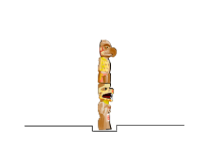
- A totem pole is placed in a 2 metre deep hole in the ground. Two ropes attached to the top of the pole are used to pull the totem pole upright. The ropes are anchored into the ground on opposite sides of the pole.
Each rope is 19 m long and is anchored into the ground 12 m horizontally from the centre of the totem pole.
- Complete the sketch to illustrate this situation.

- Calculate to the nearest tenth of a degree, the angle of
elevation of the top of the totem pole from the point
where the tope is anchored into the ground.

- Determine, to the nearest 0.1 m, the length of the totem pole before it was placed in the ground.

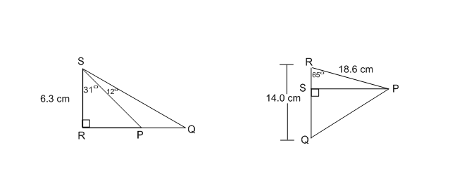

- Determine the length of PQ, to the nearest 0.1 cm.
A) B)

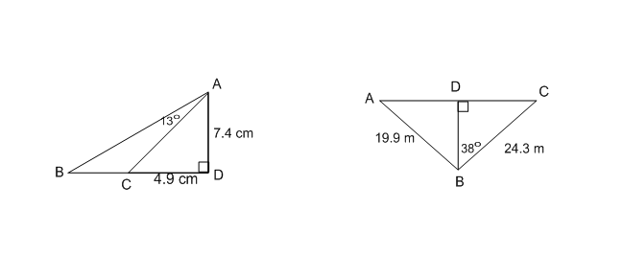

- Determine the measure of angle ABC, to the nearest degree.
- B)

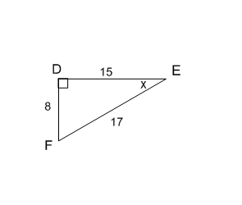
Trigonometry Practice Test

Use the following information to answer the first three questions.

- The value of $\cos{F}$ is
- $\frac{8}{15}$
- $\frac{8}{17}$
- $\frac{17}{8}$
- 62

- The value of x is
- $\frac{15}{17}$
- $\frac{8}{17}$
- 28
- 62

- Which statement is false?
- $\cos{E=\sin{F}}$
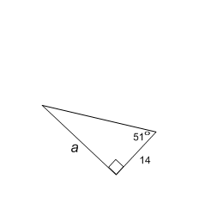
- $\sin{E=\cos{F}}$
- $\tan{E=\tan{F}}$
- $\tan{F=\frac{\sin{F}}{\cos{F}}}$

- The value of a is
- $14 tan 51°$
- $\frac{14}{\tan{51°}}$
- $14 cos 51°$
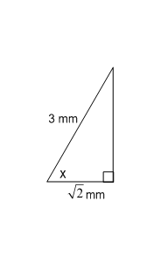
- $\frac{14}{\cos{51°}}$

- The value of x, to the nearest tenth of a degree, is
- $35.0°$
- $61.9°$
- $72.3°$
- $29.3°$

- A guy wire attached to a pole makes an angle of 71.4º with the level ground. It is 13.8 feet from the pole at ground level. How far above the ground is the guy wire attached to the pole?
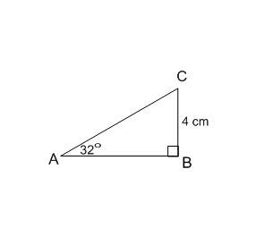
- 4.6 feet
- 13.1 feet
- 14.6 feet
- 41.0 feet

- The value of length AC, to the nearest tenth, is
- 0.1
- 2.1
- 7.2
- 7.5

- A man, six feet tall, casts a shadow of 10.6 feet. The angle of elevation of the sun is
- 30º
- 34º
- 56º
- 60º
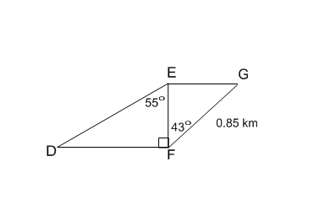
Use the following information to answer the next three questions.
The diagram shows how a horse breeder has used fencing to divide a parcel of land into two triangular paddocks for his horses. Each of the line segments represents fencing.

- The length of the fencing represented by DF is
- 0.89 km
- 0.79 km
- 0.62 km
- 0.58 km

- The value of cos G is
- 0.68
- 0.72
- 0.80
- Impossible to determine from the given information
- The total area of the two triangular paddocks, to the nearest 0.1 km², is _______.

Record your answer in the numerical response box.

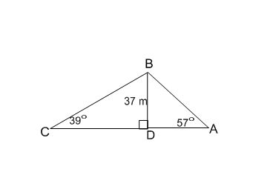
- The length of AC, to the nearest metre, is
- 54 m
- 70 m
- 87 m
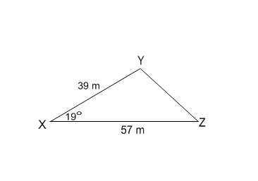
- 103 m

- Determine the area of the following triangle to the nearest square centimetre.

Record your answer in the numerical response box.

- $∆ABC$is isosceles with AB = CB. The area of the triangle is 30 cm² and AC = 12 cm. The measure of <ABC, to the nearest degree, is
- 100º
- 50º
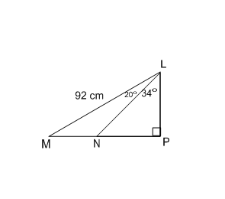
- 45º
- 23º

Use the following diagram to answer the next two questions.

- The length of LP, to the nearest centimetre, is
- 51 cm
- 54 cm
- 74 cm
- 76 cm

- The length of MN, to the nearest centimetre, is Record your answer in the numerical response box.

Answer Key
Triangle | Opposite Side | Adjacent Side | Hypotenuse | Sine Ratio | Cosine Ratio | Tangent Ratio
A) | PR | RQ | PQ | $$\frac{PR}{PQ}$$ | $$\frac{RQ}{PQ}$$ | $$\frac{PR}{RQ}$$
B) | LM | LN | MN | $$\frac{ML}{MN}$$ | $$\frac{LN}{MN}$$ | $$\frac{ML}{LN}$$
C) | BC | AC | AB | $$\frac{BC}{AB}$$ | $$\frac{AC}{AB}$$ | $$\frac{BC}{AC}$$
2.1:
1.

2. A) $\sin{c= \frac{3}{5}}$ $\cos{c= \frac{4}{5}}$ $\tan{c= \frac{3}{4}}$ B) $\sin{c= \frac{3}{5}}$ $\cos{c= \frac{4}{5}}$ $\tan{c= \frac{3}{4}}$
3. A) $\sin{A= \frac{5}{13}}$ B) $\cos{B= \frac{4}{5}}$ C) $\tan{x= 1}$ 4. A 5. D 6. C

2.2:
1. A) a = 10.5 B) e = 2.7 C) c = 4.4 2. 34 m 3. 11.1 m
4. A) 10.5 mm B) 1.1 C) 6.5 in
5.A) No side length given b) The triangle does not have a right angle. C) No angle given.
6. D 7. 324 8. 66

2.3:
1. A) 13º B) 37º C) x = 41º y = 49º
2. A) AD = 56 B) 33º 3. A) 67º B) 100º
4. 5.23º 5. A 6. 35 7. 57.4 8. 33.1

2.4:
1. <ABC = 37º <BAC = 53º <ACB = 90º AB = 48 AC = 29 BC = 38
2. <DEF = 90º <EDF = 50º <DFE = 40º DF = 173 mm DE = 111 mm EF = 133 mm
3. A) 86 m B) 21º 4. B) 4.06 m and 4.94 m
5. B) 50.8º C) 16.7 m 6.A) 2.1 cm B) 17.9 cm 7. A) 43º B) 54º

Practice Test:
1. B 2. C 3. C 4. A 5. B 6. D
7. D 8. A 9. A 10. A 11. 0.5 12. B
13. 362 14. A 15. B 16. 38

