Unit C Cycling of Matter in Living Systems
Summative Assessment

On a stage in front of an audience of thousands, a futuristic-looking machine squirted gel from a nozzle. Layer by layer, it built up the material, shaping it into a curved, pink, kidney-shape structure based on a medical CT scan of a real organ.
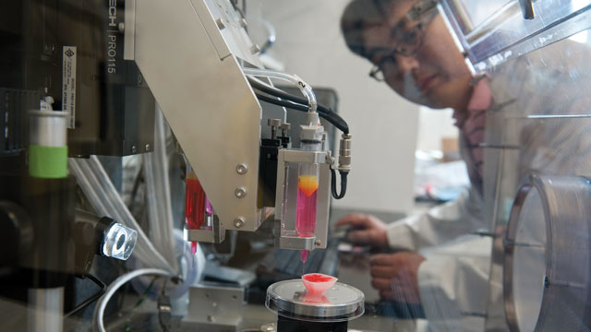
It was 2011, and Anthony Atala, director of the Wake Forest Institute for Regenerative Medicine, was demonstrating his progress in using three-dimensional (3-D) printing to make a kidney during his TED Talk. Atala had printed a kidney-shape “mold” made of biocompatible materials combined with cells. The prototype, as Atala calls it, lacked the kidney’s intricate inner structures and could not have functioned as a real organ and thus was not ready for transplantation.
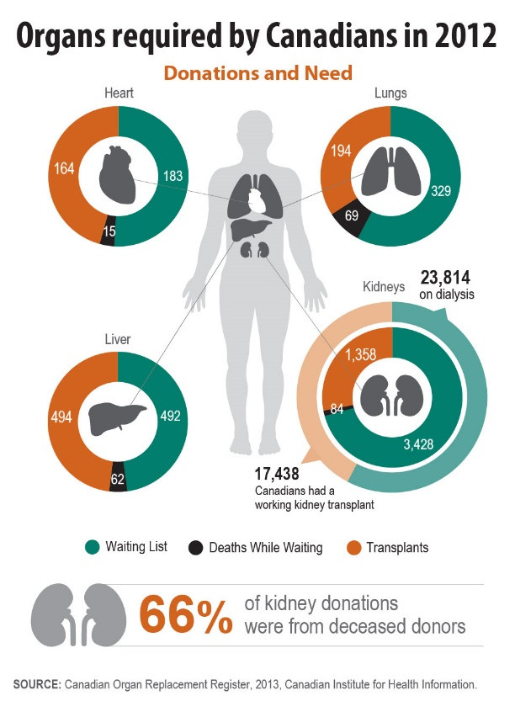
Most Canadians waiting for an organ donor are in need of a kidney. Since kidney disease is on the rise in Canada, the need for donors is growing. In 2011, 256 people died waiting for a transplant—a third of them needed a kidney. By the end of 2012, there were more than 41,000 people living with end-stage kidney disease — 42 per cent with a kidney transplant, 58 per cent on dialysis.
Bio-printing promises to change the way the medical community deals with organ transplants. As our population ages, the need for organ and tissue donations will increase. The demand for donor organs far exceeds the supply, leaving helpless patients in a state that no one should have to be left in… waiting to live
What if you could order from a catalogue a kidney or more specifically a kind of cell that your body is in desperate need of to survive? The future of bio printing and stem cell research makes that a possibility.
After some research and investigation into the complexities of our body’s cells, you will have access to technology that will provide you with the opportunity to design and print a 3-D model of a cell you would find in an organ in your body.

In this project you will be assessed on your degree of understanding, demonstration and awareness of the following essential I can statements:
- I can describe the function of cell organelles and structures in a cell, in terms of life processes, and use models to explain these processes and their applications
- I can compare the structure, chemical composition and function of animal cells, and describe the complementary nature of the structure and function of animal cells
- I can identify the structure and describe, in general terms, the function of the cell membrane, nucleus, lysosome, vacuole, mitochondrion, endoplasmic reticulum, Golgi apparatus, ribosomes, chloroplast and cell wall, where present, of plant and animal cells
- I can describe the cell as a functioning open system and describe the role of the cell membrane in maintaining equilibrium while exchanging matter and energy
- I can describe cell size and shape as they relate to the function of the cell
- I can explain the relationship between developments in technology and the current understanding of the cell
- I can identify areas of cell research
- I can compare passive transport (diffusion and osmosis) with active transport
- I can explain cellular transportation in terms of the particle model of matter, concentration gradients, equilibrium and protein carrier molecules
- I can describe how knowledge about semi-permeable membranes, diffusion and osmosis is applied in various contexts
- I can use a model to explain and visualize complex processes like diffusion and osmosis, endo- and exocytosis, and the role of cell membrane in these processes

The following competencies are focused on to ensure the development of scientific inquiry skill:

- Initiating and Planning
- Performing and Recording
- Analyzing and Interpreting
- Communication and Teamwork

The degree to which you show an understanding, demonstration and awareness of the following outcomes and competencies will be graded with the following rubric:
Descriptors | Not Meeting | Basic | Adequate | Competent | Skilled | Exemplary
Proficiency Level Descriptions | You are not yet demonstrating a basic understanding of curricular outcomes and competencies | You are demonstrating a basic understanding of curricular outcomes and competencies in limited ways | You are independently demonstrating an adequate understanding of curricular outcomes and competencies in some ways | You are demonstrating a competent and sometimes complex understanding of the curricular outcomes and competencies in appropriate ways. | You are skilled at demonstrating a complex understanding of the curricular outcomes and competencies in many ways. | You are demonstrating exemplary and complex understandings, connections and application of curricular outcomes and competencies in a variety of ways.
Letter Representations | NM | B | A | C | S | E
Scaled Rubric | 1 | 2 | 2.5 | 3 | 3.5 | 4
Grade Ranges | <50% | 50 - 65%  60 | 65 - 75%  75 | 75 - 85%  85 | 85 - 95%  95 | 95 - 100%  100
Adapted from Robert Thirsk High School

In order to receive credit students must achieve an adequate level of proficiency. Students will be required to redo parts or all of the project to ensure this level is achieved.

Note:
Outcomes - statements from the programs of study that describe what you are expected to know and be able to do in a subject.

Competencies – interrelated attitudes/skills/knowledge that are demonstrated through the outcomes, present in the front part of the programs of study and essential for exemplary success in the discipline in school and in the world – collaboration, problem solving, global understanding are examples …

Using the provided rubric determine what grade would you give yourself for your project?

Explain why you gave yourself this grade. Be specific and reference the rubric:

How did you manage your time and schedule in order to successfully complete this project?

What personal strengths did you demonstrate while working on this project?

What challenges and/or risks did you face in completing this project? Consider emotional and intellectual challenges – not just physical challenges.

List at least 3 things you know after completing your entire project.
1.

2.

3.

If you were to begin the project again, what would you do differently – especially in terms of organizing your time/material/resources more effectively?

Part I
In this part of the assignment you will be working toward mastering the following outcomes:
- I can explain the relationship between developments in technology and the current understanding of the cell
- I can identify areas of cell research
In this part of the assignment you will be required to:
- Investigate issues in organ transplants globally. How can someone become an organ donor in Canada? Create a web that summarizes your findings.
- Research 3D bio printing. Be sure to answer the following questions as you explore this very exciting advancement in regenerative medicine. Use the graphic organizer provided to assist you.
3-D Bio printing
- What is it? How does it work? What is it currently used for?
- How will it change the field of medicine? Specifically how will 3-D printing change organ transplants?
- What are the benefits of printing organs with 3-D technology? What are the limitations of printing organs?
- What are stem cells? How are they used in conjunction with 3-D printing in organ transplants?

- Watch and respond (using SOIP) to the TED Talk from Surgeon Anthony Atala demonstrating an early-stage experiment that could someday solve the organ-donor problem (https://www.ted.com/talks/anthony_atala_printing_a_human_kidney)
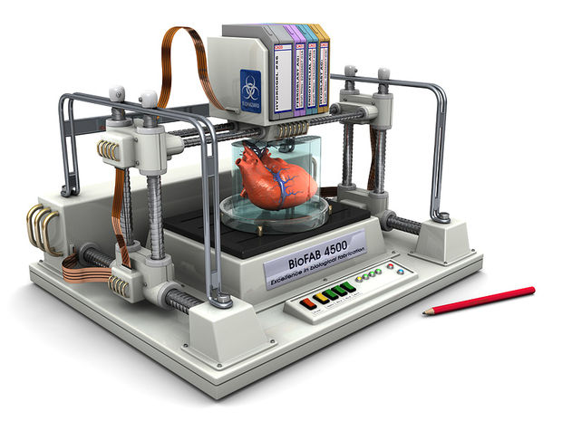
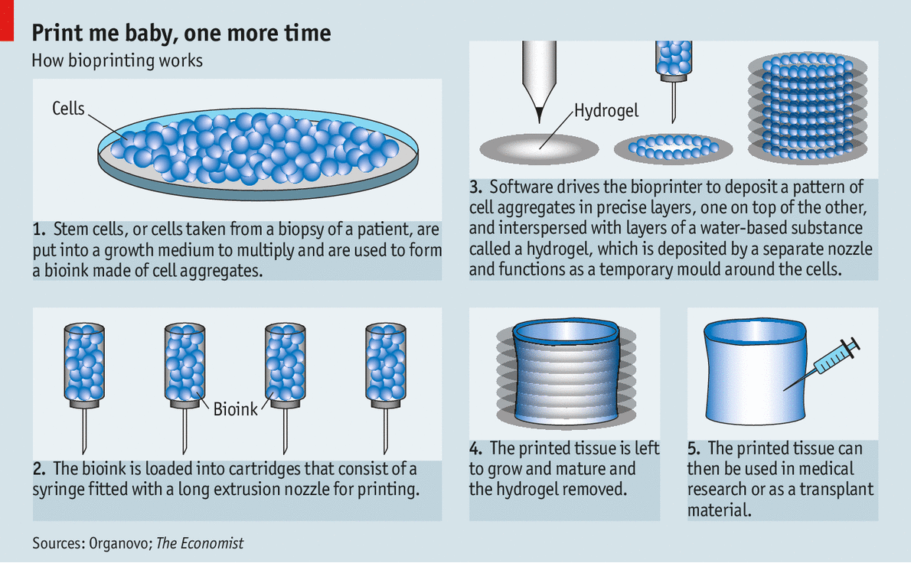

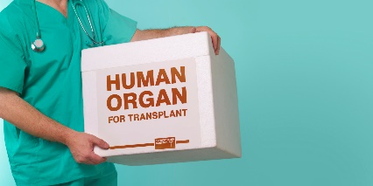

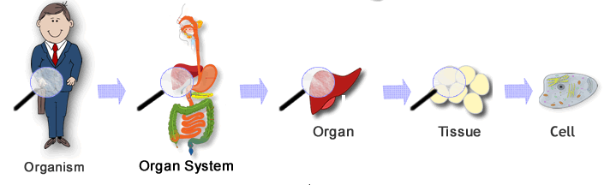
Part II
In this part of the assignment you will be working toward mastering the following outcomes:
- I can describe the function of cell organelles and structures in a cell, in terms of life processes, and use models to explain these processes and their applications
- I can compare the structure, chemical composition and function of animal cells, and describe the complementary nature of the structure and function of animal cells
- I can identify the structure and describe, in general terms, the function of the cell membrane, nucleus, lysosome, vacuole, mitochondrion, endoplasmic reticulum, Golgi apparatus, ribosomes, chloroplast and cell wall, where present, of plant and animal cells
Atala’s kidney prototype represents both the promise of 3-D printing in a medical context and the hurdles that tissue engineers have yet to clear. With recent technological advances, using 3-D printing to shape gel scaffolds that can be embedded with living stem cells into the general form of organs has become a relatively achievable task.

Cells are the basic unit of life. All living things are made up of cells that combine to create an organism as a whole. There are many different types of cells in an organism that serve different functions for the body and work together to make up organs. But what makes up a single cell? There are multiple structures, or organelles, that work together to produce a functioning cell in an organism. Each organelle carries out a specific duty to maintain the cell.

In this part of the assignment you will be required to:
- Draw pictures and describe the function of EACH of the cell organelles listed below. Draw, label and color a picture of a GENERIC animal cell and a GENERIC plant cell and the basic organelles that those cells contain. Each picture should include a description of the function of that organelle
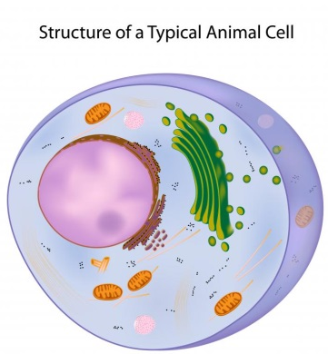
Organelles:
- Cell Membrane
- Nucleus and nucleolus
- Mitochondria
- Endoplasmic Reticulum and Ribosomes
- Lysosomes
- Golgi Complex/Apparatus
- Chloroplasts
- Large Central Vacuole

- Identify a person in society who performs similar tasks in their daily routine as the various organelles of a typical cell. Create a chart to list the people and their cellular equivalent. Explain why each analogy equivalent makes sense.

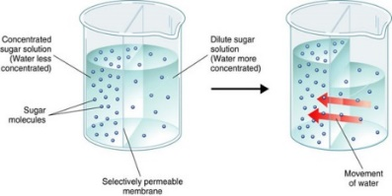
Part III
In this part of the assignment you will be working toward mastering the following outcomes:
- I can describe the cell as a functioning open system and describe the role of the cell membrane in maintaining equilibrium while exchanging matter and energy
- I can describe cell size and shape as they relate to the function of the cell
- I can compare passive transport (diffusion and osmosis) with active transport
- I can explain cellular transportation in terms of the particle model of matter, concentration gradients, equilibrium and protein carrier molecules
- I can describe how knowledge about semi-permeable membranes, diffusion and osmosis is applied in various contexts
- I can use a model to explain and visualize complex processes like diffusion and osmosis, endo- and exocytosis, and the role of cell membrane in these processes
Organs for transplant require a maintenance of their metabolism. The cells in the organs to be transplanted lack vital materials such as oxygen, sugars and amino acids. To maintain the metabolism of vital materials, the organs are preserved in solutions which contain these materials and kept at colder temperatures.
A cell, as well as the organelles inside it, are enclosed, or defined by membranes. Every cell is covered by a membrane that controls what can enter and leave the cell or the organelle. Cell membranes are made of phospholipid molecules that arrange themselves into two rows called a bilayer. Proteins are embedded in the phospholipid bilayer, through one or both layers. These proteins help other molecules cross the membrane and perform a variety of other functions.

In this part of the assignment you will be required to:
- Using a model or diagram explain why it is important for cells to have a large surface area to volume ratio
- Create a model of a small section of cell membrane. On your labeled model/diagram be sure to include:
- The semi permeable phospholipid bilayer, 2 channel proteins, and 2 carrier proteins.
- a table that tells you amount (%) of each of the membrane materials.
- a representation of passive and active transport
- Create a table that compares and contrasts the processes of osmosis, diffusion, facilitated diffusion, endocytosis, exocytosis and active transport.
- Explain what is happening in terms of cell membrane transport between the organ and the solution that surrounds the cells of an transplanted organ and why it is so important to be placed in a cold concentrated solution while waiting to be placed in the human body.
- Choose one of the following situations (on next page) to explore the application of cell membrane further.
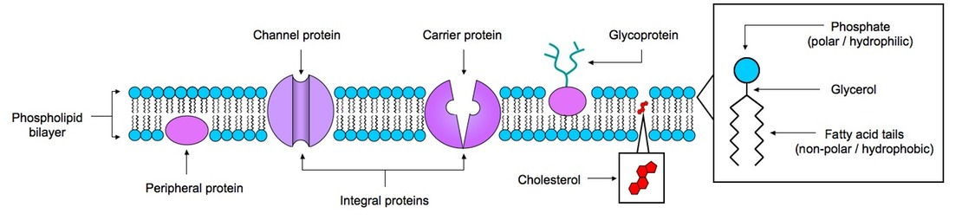

Situation A
We have already seen 3D printing create several types of human tissue, most notably liver tissue which is currently being used in drug toxicity testing. With that said, there is still one major hurdle to get us from the tiny sheets of 3D printed organ tissue, to that of entire 3D printed organs, which could one day be created by a patient’s own stem cells, and transplanted to save their life. That hurdle is the vascularisation of those organs. Every cell within a human organ, such as the liver, kidney or heart are within a hair’s width of a blood supply. This is an incredibly complex setup, one which up until now, researchers have found to be a nightmare to overcome when dealing with bioprinting.

Explain, in terms of cell transport, why an adequate vascular network (ie blood vessels) is so important to the survival of the printed organs. Consider that without blood vessels the cells would be starved of oxygen, as well as lack a means to excrete waste.

Situation B
Before the process of dialysis was available, people who experienced total kidney failure died. The purpose of dialysis is to rid the blood of toxins, wastes and excess fluid. Normally, healthy kidneys would perform this task, sending wastes to be eliminated in the urine. Today, availability of dialysis and kidney transplants means that many patients can continue to live full lives. To types of dialysis are possible: peritoneal dialysis and hemodialysis. Both are based on the principles of diffusion and osmosis and the operation of concentration gradients.

Consider how knowledge of diffusion, osmosis, active transport and semi permeable membranes was used to develop the technology of dialysis that is now used to save so many lives. Explain how the transport of wastes out of the blood during dialysis depends on the composition of the dialysis solution.

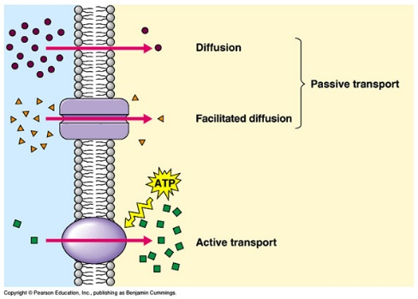

Part IV
In this part of the assignment you will be working toward mastering the following outcomes:
- I can describe the function of cell organelles and structures in a cell, in terms of life processes, and use models to explain these processes and their applications
- I can explain the relationship between developments in technology and the current understanding of the cell
- I can identify areas of cell research
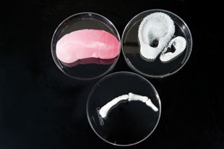
Although cells come in a variety of shapes: some are spheres, some are long wires, some are tubes, and some are even cubes. These cells all have different jobs for the organism. As researchers modify and build devices that print with ever greater precision, and invent new biomaterials to serve as ink for these machines, they have been able to make substantial progress on printing ears, spinal discs, heart valves, and bone. Similarly, simple engineered tissues, such as tracheas and bladders made from cells seeded onto biocompatible scaffolds and created without the use of 3-D printing, have already been inserted into patients. Printing a liver or a kidney that functions in the same way and with the same efficiency as a real organ, however, is a different story.
In this part of the assignment you will be required to:

- Choose a specific organ that you think would be a number one priority to learn how to print in the future.
- List the specific kinds of cells you would need to populate a scaffold of that organ (eg. Muscle, blood, nerve etc)
- Use a graphic organizer, like a Venn Diagram, to compare two of those specific types of animal cells and describe how the cell size, shape and organelles present relate to the function of that specific cell.
- Choose one of those cells and investigate what that cell would look like and what kind of specific organelles are present. Sketch a diagram of that cell.
Check with the teacher before you continue
- Create a 3D model of your cell using either option presented below:
Option 1: Use the computer to design your 3D version of the cell
Option 2: Build your own 3D version of the cell using your own materials
