Unit C Cycling of Matter in Living Systems

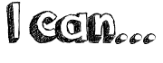
- I can describe the function of cell organelles and structures in a cell, in terms of life processes, and use models to explain these processes and their applications
- I can compare the structure, chemical composition and function of animal cells, and describe the complementary nature of the structure and function of animal cells
- I can identify the structure and describe, in general terms, the function of the cell membrane, nucleus, lysosome, vacuole, mitochondrion, endoplasmic reticulum, Golgi apparatus, ribosomes, chloroplast and cell wall, where present, of plant and animal cells
- I can describe the cell as a functioning open system and describe the role of the cell membrane in maintaining equilibrium while exchanging matter and energy
- I can describe cell size and shape as they relate to the function of the cell
- I can explain the relationship between developments in technology and the current understanding of the cell
- I can identify areas of cell research
- I can compare passive transport (diffusion and osmosis) with active transport
- I can explain cellular transportation in terms of the particle model of matter, concentration gradients, equilibrium and protein carrier molecules
- I can describe how knowledge about semi-permeable membranes, diffusion and osmosis is applied in various contexts
- I can use a model to explain and visualize complex processes like diffusion and osmosis, endo- and exocytosis, and the role of cell membrane in these processes

WORD | Definition
equilibrium
plasma membrane
phospholipid bilayer
fluid mosiac model
diffusion
osmosis
concentration gradient
semi permeable membrane
selectively permeable membrane
passive transport
active transport
channel proteins
carrier proteins
facilitated diffusion
endocytosis
exocytosis
Magnification
Diaphragm
Fine adjustment knob
Stage
arm
Compound Light microscope
Electron microscope
Field of view

Eyepiece/ocular lens

Revolving nose piece

Objective lenses

Coarse adjustment knob

Ribosome

Golgi apparatus

Cell theory

Cell organelles

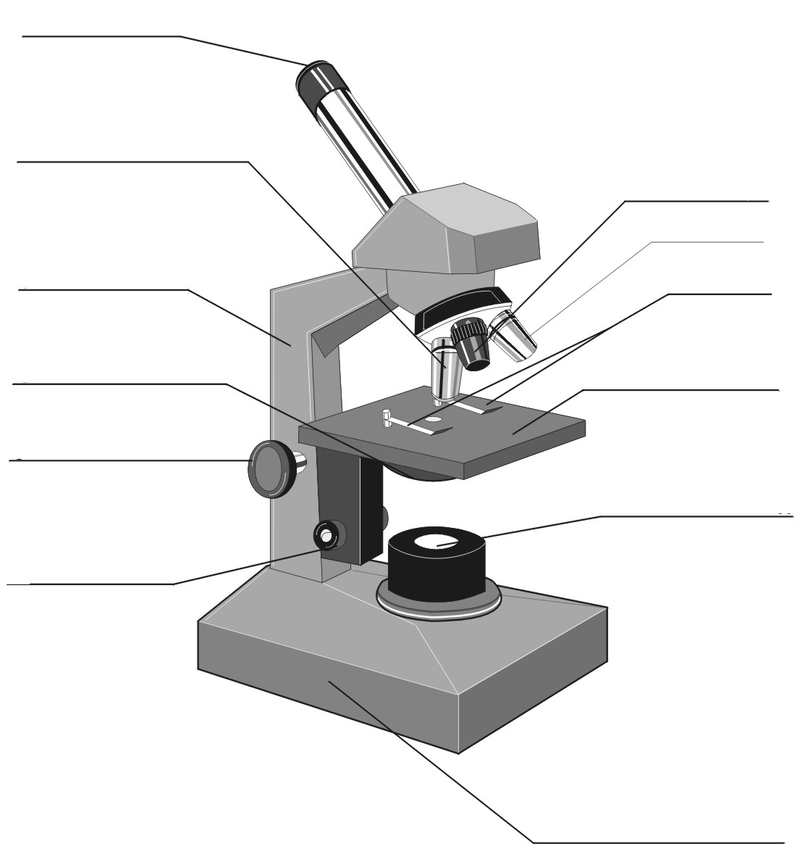
Draw, label and color a picture of a GENERIC animal cell
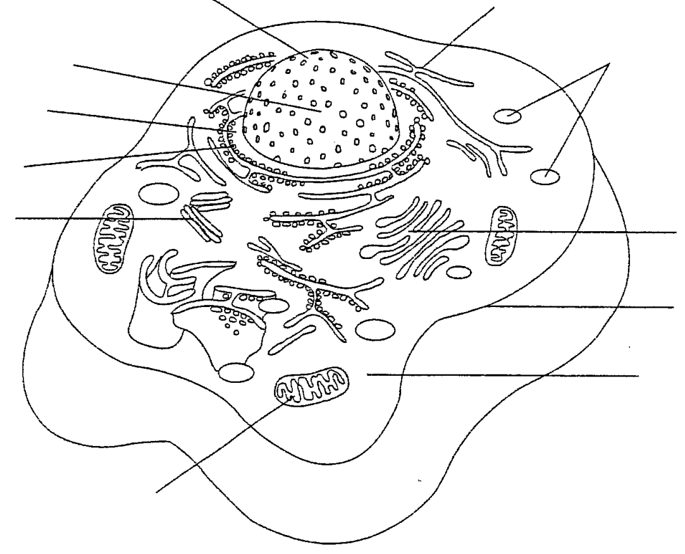
Draw, label and color a picture of a GENERIC plant cell

Draw pictures and describe the function of EACH of the cell organelles listed below.
Organelle | Diagram | Function | Analogy
Cell Membrane
Nucleus and nucleolus
Mitochondria
Endoplasmic Reticulum
Ribosomes

Lysosomes
Golgi Complex/Apparatus
Chloroplasts
Large Central Vacuole

Paste your labelled model/diagram of a small section of cell membrane here.

Complete the table that compares and contrasts the processes of osmosis, diffusion, facilitated diffusion, endocytosis, exocytosis and active transport.
Method and Definition | Energy Required? | Molecules involved | Concentration Gradient

