Math 30-2 Name:

Assignment 1: Characteristics of Exponential Functions and Solving Exponential Functions

1. Fill in the following chart:

|  |  |  |  |
| --- | --- | --- | --- |
|  |  |  |  |
| **Domain** |  |  |  |
| **Range** |  |  |  |
| **x-intercept** |  |  |  |
| **y-intercept** |  |  |  |
| **Equation of Asymptote** |  |  |  |
| **Increasing or Decreasing?** |  |  |  |

1. Determine the equation for each graph:

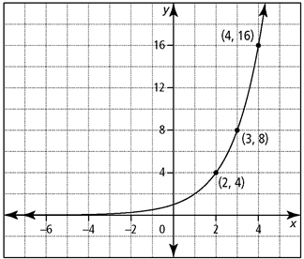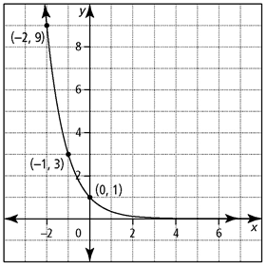a. b.

1. Algebraically solve each of the following equations:

a.  b. 

c.  d. 

e.  f. 

g.  h. 

i.  j. 

k.  l. 

1. Describe how to determine the solution of graphically, and give the value of *x* to the nearest tenth.

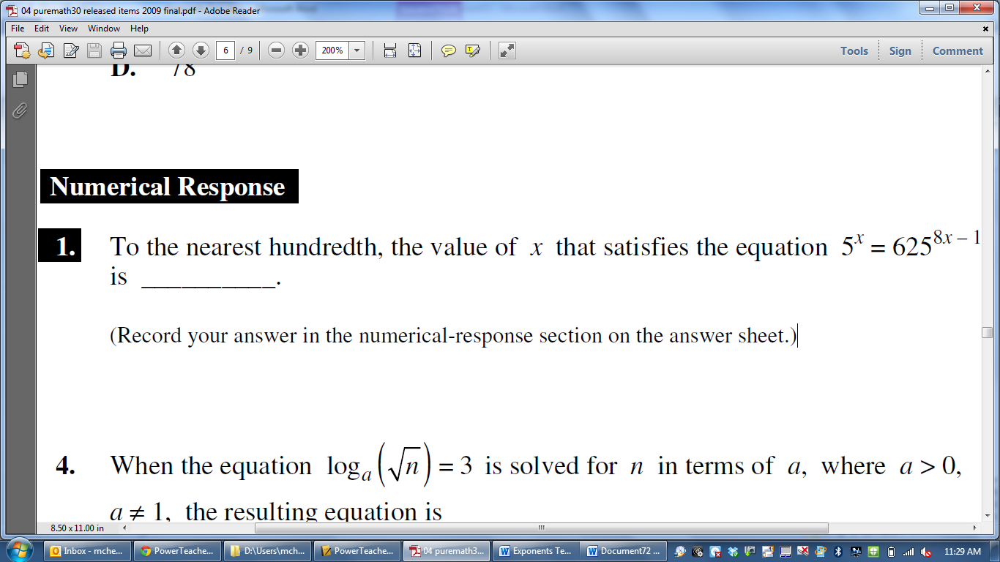

1. 