Math 20-1 Name: _________________________________

Assignment 2: Sine and Cosine Laws

  

Find the measure of the indicated side or angle in the following triangles. Round answers to the nearest whole numbers. (2 marks each)

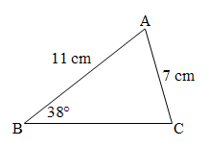

?





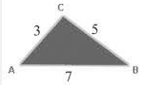

?

1. Solve the following triangle. (3 marks)

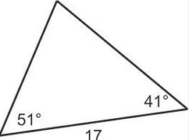

1. ∆ABC has A = 29⁰, a = 11 cm, and b = 20 cm. Determine all possible angles that can satisfy the following triangle. (3 marks)
2. Two cabins, A and C, are located 450 m apart on the bank of a river.

Across the river from the two cabins is a boathouse B. Calculate the width of the river to the nearest meter. (4 marks)

450 m





C

A

B

1. 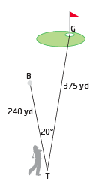The 12th hole at Lone Tree Golf and Country Club is a 375 yard straightaway par 4. When Tom tees off, the ball travels  to the left of the line from the tee to the hole. The ball stops 240 yards from the tee (point B). Determine how far the ball is from the center of the hole to the closest yard. (3 marks)
2. 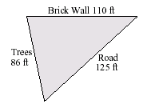A triangular yard is bounded by a brick wall, a road, and a row of trees. The wall is 110 feet long, the road is 125 feet long, and the row of trees is 86 feet long.

Calculate the measure of the smallest angle to the nearest degree. (2 marks)

1. Alex is in a watchtower. Bob and Cathy are checking out hot spots for forest fires. The watchtower is 100 m high. Cathy reports that she has found a small fire; she estimates her angle of elevation to the tower to be 18º. Alex radios the information to Bob. Bob estimates his angle of elevation to Alex to be 30º.

Alex (A)

100 m

y

x

18º

30º

110

a) How far is Bob from the base of the tower to the nearest metre?

b) How far is Cathy from the base of the tower to the nearest metre?

c) How far apart are the fires to the nearest metre?

(3 marks)

Bob (B) z Cathy (C)