Math 30-2 Name:
Assignment 2: Word Problems and Regressions

1. Kirsten has been recording the bounce heights of a ball. She determined that her data could be modeled by the exponential function , where h(x) represents the height of the ball in centimeters and x represents the number of bounces.

a. From what height was the ball first dropped(nearest whole number)? [1 mark]

b. What was the height of the ball on the sixth bounce(nearest tenth)? [1 mark]

2. Determine the equation of the exponential regression function for the data. Round all values to the nearest hundredth. [1 mark]

x | 0 | 1 | 2 | 3 | 4 | 5
y | 6.4 | 8.2 | 10.5 | 13.0 | 16.1 | 20.4

3. The population of a town can be modelled by the exponential equation

where y represents the number of people and x represents the time, in years, after 2010.

a) Is the population of the town increasing or decreasing? Explain how you know.

b) What does the constant term, a, represent? Explain how you know.

c) Estimate the population of the town in 2015. Show your work.

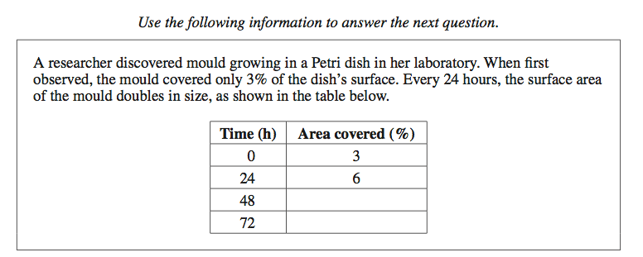
4. a. Complete the table above and then write an exponential function to model the growth of the mould over time. [2 marks]

b. Sketch the graph (make sure to label). Identify: [5 marks]
  - Domain and Range
  - x and y-intercepts

c. Use your function from part (a) to determine the approximate length of time, to the nearest tenth of an hour, it will take for the Petri dish to be completely covered with mould. [1 mark]

5. The stock of a high flying cell phone manufacturer has been collapsing as of late. Janice, a stock watcher of “BarryBlack Cellphone Corp” has been tracking stock prices for the last six months and has come up with the table below:
Date | Month 0 | Month 1 | Month 2 | Month 3 | Month 4 | Month 5
Price | 121.95 | 100.00 | 82.00 | 67.24 | 55.14 | 45.21

a. By dividing any month by the previous month’s stock price, at what percentage rate is the stock declining? [1 mark]

b. At this rate, what will the stock price be in December (month 12)? [1 mark]

c. Janice thinks this stock will be a good purchase when it hits about $5.00 per share. When should she start thinking of purchasing stock in “BarryBlack”? [1 mark]

6. The following data table shows the amount of caffeine in Giancarlo’s system after drinking an energy drink containing 74 mg of caffeine.
Hours | 0 | 1 | 3 | 5 | 6
Caffeine (mg) | 74 | 43 | 25 | 14 | 10

a) Use exponential regression to model the data. Round all values to the nearest hundredth.

b) Estimate the amount of caffeine in his system after 2 h, to the nearest milligram. Show your work.

c) Estimate the amount of caffeine in his system after 10 h, to the nearest milligram. Show your work.
7. Thorium-227 has a half-life of 18.4 days. The remaining amount of a 50-mg sample of thorium-227 can be modelled by the equation
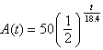

where A(t) is the amount of thorium-227 remaining, in milligrams, and t is the time in days.

a) Determine the amount of thorium-227 remaining after 10 days, to the nearest milligram. Show your work.

b) Determine the amount of thorium-227 remaining after 100 days, to the nearest tenth of a milligram. Show your work.

8. Use exponential regression to extrapolate the value of y when x = 6. Round your answer to the nearest whole number.

x | –2 | –1 | 0 | 1 | 2 | 3
y | 77 | 65 | 56 | 47 | 40 | 34

9. Use exponential regression to interpolate the value of y when x = 10. Round your answer to the nearest tenth.

x | 0 | 2 | 5 | 7 | 12 | 14
y | 51.6 | 28.2 | 11.5 | 6.3 | 1.4 | 0.8

