Unit 2: Dynamics – Friction

Practice Problems
1. A 15 kg box is being dragged over a concrete floor with an applied horizontal force of 40 N. If the coefficient of kinetic friction is 0.25, what is the acceleration of the box? (0.21 m/s²)

2. A 20 kg apple crate is being dragged across a floor at constant velocity with a horizontal force of 25 N. What is the coefficient of friction? (0.13)

3. A rope attached to a 50 kg box is being pulled at an angle of 25º across a horizontal floor where the coefficient of static friction is 0.20. What is the acceleration of the box if a 200 N force is applied? (2.0 m/s²)

4. For each situation below, draw accurate free-body diagrams showing all forces acting on the rock.
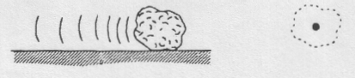
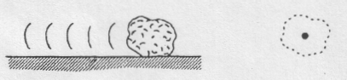
B. Decelerating because of kinetic friction.
A. Sliding at constant speed without friction.

5. It takes a 50 N horizontal force to pull a 20 kg object along the ground at constant velocity. What is the coefficient of friction? (0.25)

6. If the coefficient of friction is 0.30, how much horizontal force is needed to pull a mass of 15 kg across a level board with constant velocity? (44 N)

7. A box, with a mass of 2.0 kg, is pulled across a level desk by a horizontal force of 4.0 N. If the coefficient of kinetic friction is 0.12, what is the acceleration of the box? (0.82 m/s²)

8. A girl pushes a light (i.e. weight is negligible) snow shovel at a uniform velocity across a sidewalk. If the handle of the shovel is inclined at 55º to the horizontal and she pushes along the handle with a force of 100 N, what is the force of friction? What is the coefficient of kinetic friction? (57 N, 0.70)

9. A 70 kg hockey player coasts along the ice on steel skates. If the coefficient of kinetic friction is 0.010, (a) what is the force of friction? (b) How long will it take him to coast to a stop, if he is initially travelling at 1.0 m/s? (6.9 N, 10 s)

10. A 10 kg box is pulled across a level floor, where the coefficient of kinetic friction is 0.35. What horizontal force is required for an acceleration of 2.0 m/s²? (54 N)

11. A boy pulls a 50 kg crate across a level floor with a force of 200 N. If the force acts at an angle of 30º up from the horizontal, and the coefficient of kinetic friction is 0.30, determine
(a) the normal force exerted on the crate by the floor, (3.9 x 10² N)
(b) the frictional force exerted on the crate by the floor, (1.2 x 10² N)
(c) the acceleration of the crate. (1.1 m/s²)

12. A can of pop (mass = 500 g) is given a shove. It slides across a table, eventually coming to a stop. If its initial velocity is 2.0 m/s, and the coefficient of kinetic friction between the two surfaces is 0.20, how far will it travel across the table? (1.0 m)

