Unit 1: Kinematics Review
The Kinematics Equations

1. A jetliner, travelling northward, is landing with a speed of 69 m/s. Once the jet touches down, it has 750 m of runway in which to reduce its speed to 6.1 m/s. Compute the acceleration of the plane during landing. (-3.1 m/s²)

2. A truck, travelling at a velocity of 33 m/s due east, comes to a halt by decelerating at 11 m/s². How far does the truck travel in the process of stopping? (+50 m)

3. A baseball is thrown upward with an initial speed of 35.0 m/s. What is its velocity at 2.00 s? (15.4 m/s up)

4. An arrow is fired straight upward with an initial speed of 15 m/s. How long is the arrow in the air before it strikes the ground? (3.1 s)

5. A golf ball rebounds from the floor and travels straight upward with a speed of 5.0 m/s. To what maximum height does the ball rise? (1.3 m)

6. A rifle bullet is shot vertically upward. Twenty-three seconds later the bullet has a velocity of 72.0 m/s, downward. What is the velocity of the bullet when the bullet leaves the rifle? (154 m/s up)

7. With what initial speed must an arrow be fired straight upward to attain a height of 110 m? (46 m/s)

8. Suppose a ball is thrown vertically upward. Eight seconds later it returns to its point of release. What is the initial velocity of the ball? (39.2 m/s up)

9. A diver springs upward with an initial speed of 1.8 m/s from a 3.0 m board. (a) Find the velocity with which the diver strikes the water. (b) What is the highest point the diver reaches above the water? (7.9 m/s down, 3.2 m)

10. Suppose a car is travelling at 12.0 m/s, and the driver sees a traffic light turn red. After 0.510 s has elapsed (the reaction time), the driver applies the bakes, and the car decelerates at 6.20 m/s². What is the stopping distance of the car, as measured from the point where the driver first notices the red light? (17.7 m)

11. A drag racer, starting from rest, speeds up for 402 m with an acceleration of +17.0 m/s². A parachute then opens, slowing the car down with an acceleration of -6.10 m/s². How fast is the racer moving 3.50 x 10² m after the parachute opens? (96.9 m/s)

12. A rocket is launched from rest with an acceleration of 20.0 m/s², upward. At an altitude of 415 m the engines are turned off, but the rocket continues to coast upward. Find the total time that the rocket is in the air, from lift-off until it strikes the ground. (35.6 s)

13. Four-tenths of a second after bouncing on a trampoline, a gymnast is moving upward with a speed of 6.0 m/s. To what height above the trampoline does the gymnast rise before falling back down? (5.0 m)

14. A life-preserver is thrown vertically upward from a rescue helicopter that is hovering 30.0 m above the ground. The initial velocity of the preserver is 20.0 m/s.
a) Calculate the velocity with which the object strikes the ground. (31.4 m/s down)
b) Calculate the time it took for the object to reach the ground. (5.24 s)

15. An object is thrown vertically upward. If this object takes 5.30 s to go up and down, what height did it reach? (34.4 m)

16. While on planet Z, a hammer is thrown vertically upward with an initial velocity of 5.0 m/s. If the object returns to the point of release in 3.0 s, what is the acceleration of a freely falling object on this planet? (-3.3 m/s²)

17. A rock is thrown upward at an initial velocity of 35.0 m/s upward.
a) What is the displacement of the rock during its 2nd second of motion? (+20.3 m)
b) What is the displacement of the rock during its 5th second of motion? (-9.15 m)

Multiple Choice Section

1. What is a vector quantity?

a) a quantity that is at rest
- a quantity that has a magnitude, unit, and direction
c) a quantity that explains why objects are in motion
d) a quantity that has only a magnitude and a unit

2. What is the displacement of a cyclist who starts at highway marker +3 km and ends at marker -7 km. Consider positive numbers as representing positions east of the centre of town.

a) 10 km [W]
b) 10 km [E]
c) 4 km [W]
d) 4 km [E]

3. What is the distance travelled by a jogger who starts at highway marker + 1 km, jogs to -5 km, and then proceeds to marker +8 km?

a) 4 km
b) 7 km
c) 13 km
d) 19 km

4. What does a straight, sloped line on a graph of position versus time tell us about the motion of an object?

a) The object is travelling with positive velocity.
b) The object is travelling with negative velocity.
c) The object is travelling with uniform velocity.
d) The object is travelling with zero velocity.

5. How is average speed calculated?

a) Average speed equals total distance divided by the change in time.
b) Average speed equals total distance multiplied by the change in time.
c) Average speed equals total displacement divided by the change in time.
d) Average speed equals total displacement multiplied by the change in time.

6. How can you find the velocity at any given point on a curve of a position-time graph?

a) Find the slope of the tangent to the curve at a given point.
b) Find the length of the tangent to the curve at a given point.
c) Find the slope of the straight line that joins the given point and the origin.
d) Find the length of the straight line that joins the given point and the origin.

7. What is acceleration?

a) an increase in velocity
b) a decrease in velocity
c) a change in the direction of the velocity
d) any change in velocity

8. On a velocity-time graph, what does a straight sloped line always represent?

a) constant displacement
b) constant velocity
c) uniform acceleration
d) constant speed

9. How do you find the displacement of a moving object from a velocity-time graph?

a) Find the slope of each straight line of the graph and add them together.
b) Find the length of each straight line and add them together.
c) Find the area under the graph.
d) Find the product of the slope of each line and the area under the graph.

10. A cyclist accelerates uniformly from rest to 5.0 m/s in 5.0 s. Describe the straight line representing the motion of the cyclist on a velocity-time graph.

a) The line is horizontal from 5.0 m/s at 0 s and extends to 5.0 m/s at 5.0 s
b) The line is descending from 5.0 m/s at 0 s to 0 m/s at 5.0 s
c) The line is rising from 0 m/s at 0 s to 5.0 m/s at 5.0 s
d) The line is vertical from 0 m/s at 5.0 s to 5.0 m/s at 5.0 s

Multiple Choice Answers

1. B
2. A
3. D
4. C
5. A
6. A
7. D
8. C
9. C
10. C
Graphical Analysis

1. The following position-time graph represents the motion of a steel ball rolling up an incline, coming to a stop, and returning back to its original position.
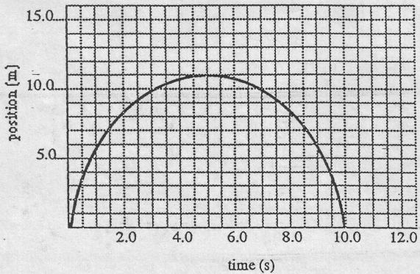
Calculate the velocity at
a) 3.0s
b) 5.0 s
c) 7.0 s

2. Given the following velocity-time graph for an object moving along a line,
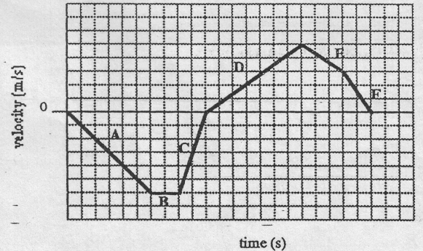
In which section(s) is the
a) displacement greatest?
b) velocity the greatest?
c) displacement positive?
d) displacement negative?
e) velocity positive?
f) velocity negative?
3. Given the following position-time graph for an object moving along a straight line, find the
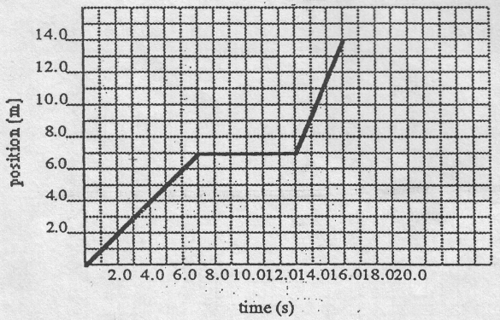

a) displacement of the object at 16.0 s
b) velocity at 5.0 s
c) velocity at 9.0 s
d) velocity at 15:0 s
e) average velocity of the motion described
f) acceleration : between 2-0 s and 6.0-s

4. Given the following velocity-time graph for an object moving along a line,

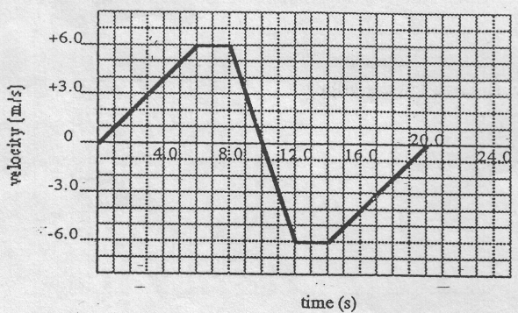
find the
a) velocity at 4.0 s
b) velocity at 7.0 s
c) velocity at 11.0 s
d) acceleration at 10.0 s
e) acceleration at 17.0 s
f) displacement at 10.0 s
g) average velocity during the total motion described

5. Given the following position-time graph for an object moving along a line,
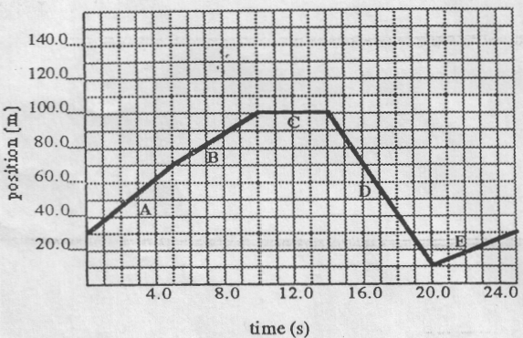
a) find
i) the velocity of the object at 17.0 s
ii) the total distance travelled by the object from the beginning to the end of the motion described in the graph
iii) the displacement of the object from the beginning to the end of the motion described in the graph
iv) the average speed of the object during the motion described in the graph.
b) during which time interval
i) does the object have a negative displacement?
ii) does the object have a negative velocity?
iii) does the object reach its highest velocity?

6. Given the following position-time graphs,
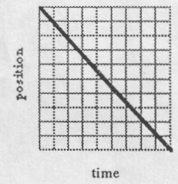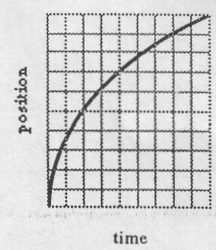

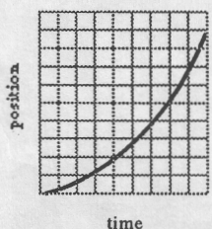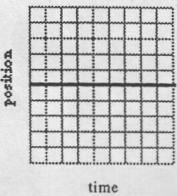
Which of these graphs represents:
a) zero velocity?
b) motion in which the velocity is increasing?
c) motion in which the velocity is decreasing?
d) motion in which the velocity is constant?

Graphical analysis answers

1. a) v = +1.0 m/s
b) v = 0
c) v = –1.0 m/s

2. a) A
b) B
c) D, E, F
d) A, B, C
e) D, E, F
f) A, B, C

3. a) d = 14.0 m
b) v = +1.0 m/s
c) v = 0
d) v = 2.3 m/s
e) v = 0.875 m/s
f) a=0

4. a) v = +4 m/s
b) v = +6 m/s
c) v = –3 m/s
d) a = –3.0 m/s²
e) a = +1.0 m/s²
fl d= + 36m
g) v_{av} = 0

5. a)
i) v = –15 m/s
ii) d = 180 m
iii) d = 0
iv) v_{av} = 7.2 m/s

b)
i) D
ii) D
iii) D

6. d c

b a

Vectors/Relative Motion
1. A man walks 400 m NORTH, 275 m WEST, 150 m SOUTH and then 650 m EAST. The trip required 15 minutes.
A. What was the total distance travelled by the man? (1475 m)
B. What was the displacement of the man? ( 451 m at 56° E of N )
C. What was the average speed of the man? ( 98.3 m/min )

2. A motorcyclist travels SOUTH at 35 m/s for 2 minutes and then he travels WEST at 27 m/s for 5 minutes.
A. What was the average speed of the motorcyclist? ( 1757 m/min )
B. What was the displacement of the motorcyclist? (9.1 km at 62.6° W of S)

3. A soccer player runs 75.0 m at 30° North of East. Then she runs 75.0 m straight West. Finally she ran 65.0 m at 60° South of East. The whole activity required 3.00 minutes.
A. What was the final displacement of the girl? ( 29.3 m at 40° S of E )
B. What was the average speed of the girl? ( 71.7 m/min )

4. A pilot heads her plane with a velocity of 255 km/h North. If there is a strong wind of 112 km/h blowing East, what is the actual velocity of the plane? ( 279 km/h at 24º E of N )

5. A boat travels directly NORTH across a river at a velocity of 1.0 m/s if the river flows at a velocity of 0.50 m/s EAST, in what direction is boat actually headed? (27° E of N)

6. A boat that can travel on still water at a speed of 3.0 m/s WANTS to travel NORTH perpendicular to the river current. If the river current is 1.2 m/s EAST, in what direction must the boat head? (24° W of N )

7. A pilot WANTS to fly WEST. If the plane has an airspeed of 95 m/s and there is a 25 m/s wind blowing NORTH, in what direction must she head the plane? ( 15° S of W )

8. A boat that can travel 4.0 m/s on still water heads directly NORTH across a river that is 125 m wide. The river current is 2.1 m/s EAST.
A. What is the velocity of the boat with respect to the shore? ( 4.5 m/s at 28 E of N )
B. How long does it take the boat to reach the opposite shore? ( 31 s )
C. How far downstream is the boat when it reaches the opposite shore? ( 66 m )
Projectile Motion
1. An arrow is fired horizontally from a bow at a speed of 57.6 m/s. If the archer is 26.2 m away from the target and is aiming directly at the bull’s eye of the target, but her arrow lands below the bull’s eye, determine how far below the bull’s eye it lands.

2. A baseball player hits a fly ball with an initial velocity of 27.2 m/s at an angle of 41.2º above the horizontal. How high does it rise?

3. A ball is thrown horizontally from a window at 24 m/s and hits the ground 1.8 s later.
(a) How far horizontally does the ball travel?

(b) How high is the window from which the ball was thrown?

4. Pedro throws a ball horizontally at a speed of 26.5 m/s. He releases it at a height of 1.90 m above the ground. Pedro’s little brother Juan throws the same ball from the same spot at a speed of 13.4 m/s at an angle of 37.0º above the horizontal. Which ball goes farther, and by how much?

