# Unit 2: Dynamics – Free-Body Diagrams and FNET

# Practice Problems

1. A 6.0 kg cart is being pulled with a horizontal force of 25 N. If the frictional force is 15 N, what is the acceleration of the cart? (1.7 m/s2)

2. A 1200 kg car comes to a stop from a speed of 25 m/s in 6.5 s. What braking force was required? (-4.6 x 103 N)

3. A 5.0 kg object experiences a 15 N force pulling north, a 25 N force pulling east and a 20 N force pulling at 30o E of S. What is the acceleration experienced by the object? (7.0 m/s2 @ 3.8o S of E)

# 4. In each case, a rock is acted on by one or more forces. All drawings are in a vertical plane, and friction is negligible (i.e. zero) except where noted. Draw accurate free-body diagrams showing all forces acting on the rock. Please use a ruler, and do it in pencil so you can correct mistakes. The one to the right is done as an example.

A. Suspended static rock

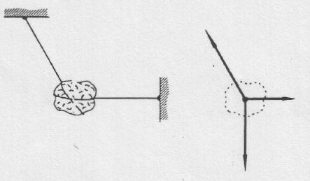







B. Rock on ground

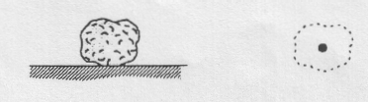

D. Suspended static rock

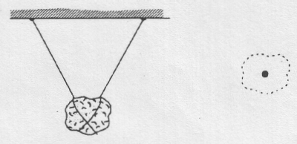

C. Suspended static rock

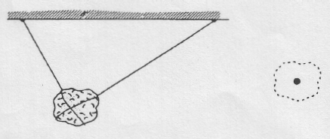

F. Rock is falling. Air friction is involved.

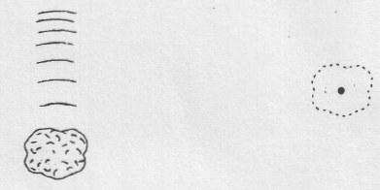

E. Rock is falling. No air friction.



G. Falling at constant (terminal) velocity.

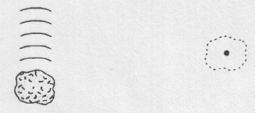

5. A 130 N eastward force is applied for 2.0 s to a 50 kg object starting from rest on a level surface. If there is a frictional force of 50 N, what is the resulting displacement of the object? (3.2 m)

6. A 300 kg object is accelerated at 0.25 m/s2 by what unknown force? (75 N)

7. A 400 g mass at rest is acted on by a 200 N net force for 12.0 s. What is its final velocity? (6.00 x 103 m/s)

8. What is the mass of an object that is acted on by a 500 N horizontal force and a 150 N frictional force if it changes velocity from 20 m/s to 40 m/s in 2.5 s? (44 kg)

9. What is the initial velocity of a 2.2 kg object that experiences a net force of 2.50 N for 8.0 s giving it a final velocity of 70 m/s? (+61 m/s)

10. A 4000 kg vehicle travelling at 26.00 m/s west is slowed to 2.000 m/s west in 20.00 s by what braking force? (4800 N east)

11. A car of mass 1500 kg is being driven at 20.00 m/s. The driver sees a massive hole 100.0 m ahead. What is the minimum frictional force required to stop the car in time? (-3000 N)

12. A bullet of mass 20 g strikes a fixed block of wood at a speed of 320 m/s. The bullet embeds itself in the block of wood, penetrating to a depth of 6.0 cm. Calculate the average force acting on the bullet to bring it to rest? (1.7 x 104 N)

13. A 40 N push north combines with a 30 N pull east. What is the net force? (50 N @37o E of N)

14. Three strings are attached to an object. If one of the strings is pulled north with a force of 10 N and one of the other strings is pulled west with 15 N, what force must be applied to the third string so that the object does not move? (18 N @34o S of E)

15. A 20 kg mass, initially at rest, is subjected to the following forces: 30 N at 30o north of east, 40 N south, and 50 N at 45o south of west. What is the acceleration of the mass? (3.1 m/s2 @ 8.8o W of S)

16. An 8.0 g bullet travelling at 400 m/s passes through a heavy block of wood in 4.0 x 10-4 s and emerges with a speed of 100 m/s. (a) With what average force did the wood oppose the motion of the bullet? (b) How thick is the block of wood? (–6.0 x 103 N, 1.0 x 10-1 m)

17. A 1600 kg car is at a stop light on a level, horizontal road. There is an average frictional force of 680 N acting on the car.

a) When the light turns green the driver accelerates the car to a speed of 72 km/h in 25 s. What was the applied force on the car during this time? (+1960 N)

b) The driver then maintains a constant speed of 72 km/h for 6.5 km. What was the applied force on the car during this time? (+680 N)

c) When the driver sees a red light ahead he slows to a stop over 32 s. What was the applied braking force on the car during this time? (–320 N)

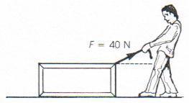

18. A man drags a package across the floor with a force of a 40 N, as shown. The mass of the package is 10 kg. If the acceleration of the package is 3.5 m/s2 and friction can be neglected, at what angle to the horizontal does the man pull? (29o)