Unit 3: Polynomial Practice Booklet
3.1 Introduction to Polynomials
1. Identify as a monomial, a binomial, or trinomial.
a) $x+1$ b) $3x^{3}$ c) $2x^{2}+2x+2$

2. State whether or not the following are polynomial expressions. If they are not polynomial expressions, explain why not.
a) $\frac{1}{2}x^{2}-3x$ b) 8$m^{-2}$ c) $\sqrt{6}$

d) $\frac{7}{x^{3}}$ e) $\frac{8x^{2}}{3}$ f) $x^{4}+3x^{1.5}$

3. Complete the following table.
Polynomial Expression | # of Variables | # of Terms | Name of Polynomial
$$2y^{3}+y^{4}-y+13$$
$$25$$
$$\frac{3}{5}x^{3}yz^{5}+3x^{2}yz^{4}$$

4. Complete the following table for the single variable polynomial.
Polynomial Expression | Leading Coefficient | Constant Term | Name of Polynomial
$$y^{4}-y+13$$
$$0.2t^{3}-0.3t^{2}+0.4t-0.5$$
$$\sqrt{5}-x^{6}$$
$$πx^{2}-7-3x$$
$$\frac{-1}{10}c^{2}$$

5. Arrange the following in descending powers of the variable.
- $6w^{2}-9w+5+2w^{3}$
- $\frac{1}{4}a^{2}-\frac{2}{3}a^{3}-1-a$
- $z-3-{4z}^{6}+z^{3}$

6. State which of the following are true and which are false.
- $-54$ is a polynomial.

- The numerical coefficient of $\frac{6x}{5}$ is 6.

- A polynomial may have 1000 terms.

- $\frac{2}{a^{3}}-1$ is a polynomial.

- The polynomial $x^{3}+2x^{2}+3x+4$ is written in ascending powers of x.

- The polynomials $3x^{2}-9x+1$ and $1-9x+3x^{2}$ are equivalent.
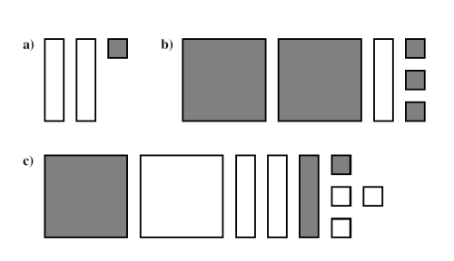
7. State the polynomial expression which describes each diagram.

8. Use algebra tiles to determine the result of the addition of:
a) $\left(x^{2}-x-3\right)+(x^{2}-2x-3)$ b) $\left(3x+1\right)+(2x^{2}-3x-2)$

9. Simplify.
a) $6p-7q-3q-2p$ b) $\frac{1}{2}x-3+\frac{3}{2}x+18$ c) $3-2x+7y+4y-2x+8z-9$

10. Simplify the following polynomial expressions by collecting like terms.
a) $\left(5a-9b-2c\right)+\left(c-7b-3a\right)$ b) $(5x^{2}-8x+3)$
- $(3x^{2}-3x-1)$

11. A triangle has a perimeter of $6m+n$ cm. One side measures $2m-3n$ cm and another side measures $3n+2m$cm. Write and simplify an expression for the length the third side of the triangle.

12. Which of the following polynomial expressions, when simplified, is equal to $5x$?
- $\left(3x^{2}-3x\right)-(2x+3x^{2})$
- $5x-\left(2x^{2}-2x\right)+(2x^{2}+2x)$
- $8+\left(4-2x\right)-(12-7x)$
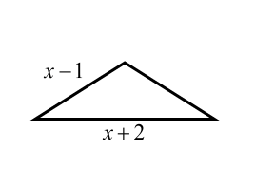
- $\left(2x^{2}-2x+6\right)-\left(2x^{2}-2x\right)+(9x-6)$

13. The perimeter of the isosceles triangle shown can be represented by
- a monomial
- a binomial
- a trinomial
- none of the above

3.2 Multiplying a Polynomial by a Monomial
1. In each case, complete the diagram, state the polynomial product in x, and express the
product as a sum or difference of terms.
- b)

2. In each case, state the polynomial product in x which is indicated by the algebra tile
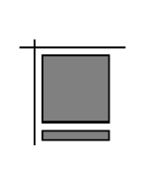
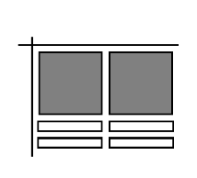
diagram. Express the product as a sum or difference of terms.

- b)

3. Expand.
a) $6(7x-3)$ b) $4x(2y+8z)$ c) $-2a(b-c+5d)$

d) $\left(2x^{2}+x-6\right)\left(-4x\right)$ e) $3\left(x+5\right)-7$ f) $2\left(x+3\right)-4\left(2x-1\right)$

4. Identify the errors in the following and provide the correct simplification.
a) $3x\left(2x+y\right)=6x+3xy$ b) $x^{2}\left(x^{3}-2x+7\right)=x^{6}-2x^{3}+7x^{2}$

c) $4\left(x-2\right)-2\left(x-3\right)$ d) $2\left(2t-3\right)-4\left(t+5\right)$ e) $5\left(a+b\right)-\left(a+b\right)$ = $4x-8-2x-6$ $=4t-3-4t-5$ $=5a+5b-a+b$
$=2x-14$ = $-8$ = $4a+6b$

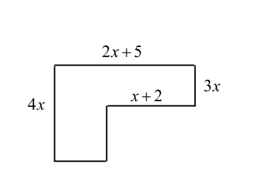

5. Determine a simplified expression for the area of the given shape.

6. Which of the following expansions is incorrect?
- $-2x^{2}\left(3x+2\right)=-6x^{3}-4x^{2}$
- $-4x\left(2-x\right)=-8x+4x^{2}$
- $-5x\left(x^{2}-3\right)=-5x^{3}-15x$
- $7x^{2}\left(x^{2}+3\right)={7x}^{4}+21x^{2}$

7. The expression $2x\left(4-3x\right)+5x\left(2x-1\right)-3\left(4x+2\right)$ can be written in the form $ax^{2}+bx+c$. The value of $a+b-c$ is _________.

Record your answer in the numerical response box.

3.3 Multiplying Two Binomials
1. Complete the algebra tile diagrams and determine and write the binomial multiplication sentence.

- b)

2. Expand.
a) $(x+6)(x-2)$ b) $(3d-5)(6d-9)$ c) $(2x-y)(4x+y)$

3. Use an area diagram and mental math (no calculator) to determine the following products.
a) $23 × 21$ b) $86×86$

4. Expand and simplify.
a) $(x+4)(x+7)$ b) $(a+7)(3a-5)$

c) $(4a+9b)(2a+3b)$ d) $(2y^{2}-3)(5y^{5}+1)$

5. A rectangle has length $2a+5$ cm and width $a+4$cm.
Determine the area of the rectangle.

6. Expand and simplify.
a) $(7x-2)(3x+5)$ b) ${(1+3b)}^{2}$

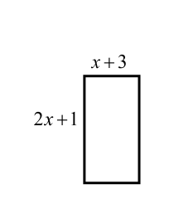
7. The area of the rectangle show can be written in the form $px^{2}+qx+r$, where $p, q, and r$ are natural numbers.
Write the value of p in the first box.
Write the value of q in the second box.
Write the value of r in the third box.

8. The expansion of $(3x-c)(x-3)$, where c is a whole number, results in a polynomial in x with a leading coefficient of 3 and a constant term of 12. The value of c is _______.

Record your answer in the numerical response box.

3.4 Multiplying Polynomials
1. Expand and simplify.
a) ${(x-8)}^{2}$ b) $(x-9)(x+9)$ c) $(9-5x^{2})(9+5x^{2})$

d) $2(4x-3)(3x-4)$ e) $\left(x-3\right)\left(x-6\right)+(x+2)(x+7)$

2. Determine the expansion using your preferred method.
a) $(y-5)(y^{2}+2y+4)$ b) $(x-4)(x^{2}-6x+3)$

c) $(x+1)(x+2)(3x+5)$ d) $2(5x+2)(3x^{2}+x-4)$

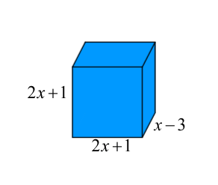

3. Calculate the volume of the rectangular prism.

3.5 Polynomial Problem Solving
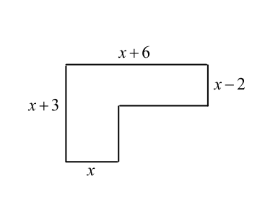
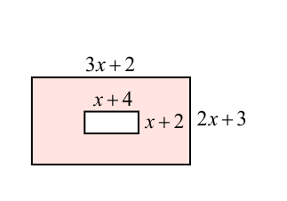
1. A) Determine the area of each figure can be written in the form $ax^{2}+bx+c$.
B) Calculate the area when $x=2.4$.
- ii)

2. A square garden of side length $3x+1$m contains two square flower beds each with a side length of $x+1$ m. The remainder of the garden is grass.

- Draw a diagram to illustrate this information.

- Write and simplify an expression for the area
of grass in the garden.

3. A rectangle has length $x^{2}+4x-1$ cm and width $3x-2$ cm.
a) Write and simplify an expression for the area of the rectangle in cm².

b) If $x=2.5$, calculate the area of the rectangle.

4. Dice for a children’s board game are cubes with an edge length of $3x-2$mm.
- Write and simplify an expression for the volume of a die in mm³.

- The manufacturer packages dice in cubic containers containing 64 dice. Determine the volume of the container in cm³ if $x=4.$

3.1-3.5 Practice Test

1. Which of the following could not be classified as a monomial?
  - $9x^{4}$
  - $x+1$
  - $7$
  - $-6x$

2. The polynomial $2x^{3}-9+8x^{4}$ has a leading coefficient P, degree Q, and constant term R. The value of $P-Q-R$ is ________.

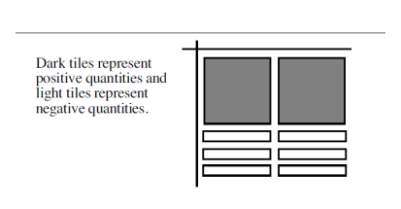
Use the following diagram to answer the next question.

3. The algebra tile diagram represents the expansion of
a) $2x^{2}(x^{2}-3x)$
b) $x^{2}(x-3)$
c) $2x(x-3)$
d) $2x(x+3)$

4. When $(x+y)(x-y)$ is expanded, how many terms are in the simplified polynomial?
  - 1
  - 2
  - 3
  - 4

5. The area (in mm²) of a rectangle with length $6-a$ mm and width $8-a$ mm is
  - $48+a^{2}$
  - $48-14a-a^{2}$
  - $48-2a+a^{2}$
  - $48-14a+a^{2}$

6. Which of the following expansions is correct?
a) $-2x^{2}\left(3x^{3}+5\right)=-6x^{6}-10x^{2}$
b) $-7x\left(2-3x\right)=-14x-21x^{2}$
c) $-5x^{3}\left(4+x\right)=-20x^{3}-5x^{3}$
d) $-9x^{2}\left(1-x\right)=-9x^{2}+9x^{3}$

7. The expression $6x\left(4-3x\right)-5x\left(x-4\right)-(9x+2)$ can be written in the form
$ax^{2}+bx+c$. The value of $abc$ is _______.

8. Triangle PQR is isosceles and right angled at Q. Side PQ measures $2x+8$ cm. If the area of the triangle can be expressed in the form $ax^{2}+bx+c$ cm², then the value of b is
a) $32$
b) $16$
c) $8$
d) $6$
9. If ${(x-a)}^{2}+a= x^{2}-12x+c$, then the value of c is ________________.

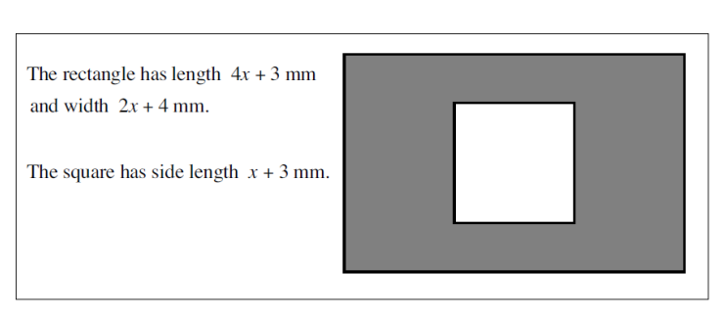
Use the following information to answer the next question.

10. The area, in mm², of the shaded region is
a) $7x^{2}+22x+21$
b) $7x^{2}+28x+21$
c) $7x^{2}+16x+3$
d) $7x^{2}+22x+3$

11. The expansion $(6t-1)(2t^{2}-7t-1)$ is
a) $12t^{3}-44t^{2}+t+1$
b) $12t^{3}-40t^{2}-13t+1$
c) $12t^{3}-44t^{2}-t+1$
d) $12t^{3}-44t^{2}-13t-1$

12. Subtracting the product of $2x-3$ and $3x+2$ from the sum of $3x^{2}+3x-2$ and
$3x^{2}+2x-4$ results in a polynomial in the form $px^{2}+qx+r$
How many of the parameters $p, q, r$ are equal to zero?
  - $0$
  - $1$
  - $2$
  - $3$

13. Expand $(a+3)(a-6)(2a+1)$
a) $2a^{3}-5a^{2}-39a-18$
b) $2a^{3}+7a^{2}-33a-18$
c) $2a^{3}+a^{2}-45a-18$
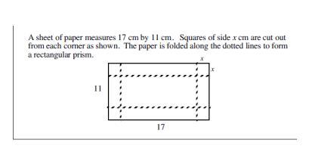
d) $2a^{3}-18$

14. The length and width (in cm) of the rectangular prism are respectively.
a) $17-x$ and $11-x$
b) $17-2x$ and $11-2x$
c) $17+x$ and $11+x$
d) $17+2x$ and $11+2x$

15. The volume of the rectangular prism can be written as the polynomial expression
$ax^{3}+bx^{2}+cx$ where a, b, and c are integers. The value of $a+c$, to the nearest whole number is, _______.

3.6 Factoring by Removing a Greatest Common Factor
1. Complete the factoring in each case.
a) $12a+24b=_______(a+2b)$ b) $4p^{2}-7p=________(4p-7)$

c) $6cde-4cd=_______(3e-2)$ d) $3y^{3}-9y=________(y^{2}-3)$

e) $3a^{2}+15a=3a( )$ f) $20p-10q=10( )$

g) $-15x^{2}y-10x^{2}y^{2}= -5x^{2}y( )$ h) 16$m^{2}n^{3}-12mn^{2}-4mn=4mn( )$

2. Factor the following polynomials by removing a greatest common factor.
a) $6m+6n$ b) $7xy^{2}+49$ c) $6x^{2}-9x$ d) $48y^{2}-72y^{5}$

3. Factor the following polynomials.
a) $12x-8y+16z$ b) $5x^{2}-10xy-20xz$ c) $14a^{2}b^{2}+21a^{3}b^{2}-35a^{2}b^{3}$

4. In each of the following:
i) Simplify the expression by collecting like terms.
ii) Factor the resulting polynomial.
- $5x^{2}-2x+7-2x^{2}+8x-7$ b) $xy^{3}-2x^{3}y+6x^{2}y^{2}-5xy^{3}+8x^{3}y$

c) $2\left(x^{3}-3x\right)-4x\left(x-6\right)+5x^{2}\left(x-2\right)-4x$

5. The surface area of a cylinder is given by the formula $A=2πr^{2}+2πrh$, where r is the radius of the base and h is the height of the cylinder.
a) Calculate the surface area, to the nearest 0.01 cm², of a cylinder which has a vertical height of
14.5 cm and a base diameter 11 cm.
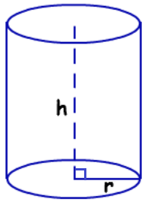

- Write the formula for A in factored form.

6. $πr^{3}+3πr$ is equivalent to
A. $3π^{2}r^{4}$
B. $3π(r^{2}+r)$
C. $πr(2r+3)$
D. $πr(r^{2}+3)$

7. One factor of $9x^{4}-6x^{3}+3x^{2}$ is
A. $9x^{4}$
B. $3x^{2}-2x$
C. $3x^{2}-6x+3$
D. $3x^{2}-2x+1$

8. When $x^{4}y^{3}-x^{2}y^{3}+x^{6}y$ is factored, the greatest common factor has degree A and the remaining trinomial factor has degree B. The value of $A+2B$ is ________.

9. When the greatest common factor is removed from the binomial $98x^{2}-28x$, the binomial can be written in the form $ax(bx+c)$. The value of $a+b+c$ is ______.

3.7 Factoring by Grouping
1. Factor the following polynomials by removing the greatest common factor.
a) $\left(3x\right)\left(x+5\right)-(7)(x+5)$ b) $2\left(4-7p\right)+3p(-4+7p)$

2. Factor the following polynomials by grouping.
a) $x^{2}+2x+6x+12$ b) $x^{2}+3x+15x+45$

c) $a^{2}-9a-5a+45$ d) $t^{2}+7t-3t-21$

e) $2x^{2}+2x+3x+3$ f) $3m^{2}+9m+5m+15$

g) $2a^{2}-6a-a+3$ h) $a^{2}+ax+ay+xy$

3. One factor of $xy-4xz-12tz+3ty$ is
A. $(4t+x)$
B. $(3t-x)$
C. $\left(y-4z\right)$
D. $(3x+t)$

4. $x\left(x-2\right)+y(2-x)$is equivalent to
A. $(x-2)(x+y)$
B. $(x-2)(x-y)$
C. $(2-x)(x-y)$
D. $(2-x)(x+y)$
5. How many of the following statements are true?
i) $p^{2}+pq+p=p(p+q)$ ii) $\frac{2}{3}πr^{3}+πr^{2}h=\frac{2}{3}πr^{2}(r+2h)$
iii) $t^{2}+t^{4}+t^{6}=t^{2}(1+t^{2}+t^{3})$

3.8 Factoring Trinomials when a=1
1. Complete the tables to find two numbers with the given sum and given product.
 | Sum | Product | Integers
a) | 5 | 6
b) | 8 | 7
c) | 11 | 30
d) | -11 | 30
 | Sum | Product | Integers
e) | 11 | 10
f) | -8 | 15
g) | -15 | 56
h) | -18 | 56

2. Factor where possible (only 1 is non-factorable).
a) $x^{2}+3x+2$ b) $x^{2}+9x+18$ c) $x^{2}-10x+21$

d) $x^{2}+10x+11$ e) $y^{2}+17y+42$ f) $x^{2}+24x+80$

g) $d^{2}+18d+45$ h) $n^{2}-23n+102$

3. A volleyball court has an area of $x^{2}+15x+36$ square metres.
a) Factor $x^{2}+15x+36$ to find binomials that represent the length and width of the court.

b) If $x=3$, determine the length and width of the court.

4. Factor.
a) $2x^{2}+6x+4$ b) $-2a^{2}-30a-108$ c) $-10a^{4}+100a^{3}-240a^{2}$

5. Which of the following is not a factor of $3m^{2}-27m+54?$
A. $m-3$
B. $m-6$
C. $m-9$
D. $3$

6. For which of the following trinomials is $a+5$ not a factor.
A. $a^{2}+6a+5$
B. $a^{2}+11a+30$
C. $a^{2}+10a+50$
D. $a^{2}+10a+25$

7. The expression $t^{2}+kt+12$ cannot be factored if $k$ has the value
A. $-13$
B. $-8$
C. $7$
D. $11$

8. The largest integer value of $b$ for which $x^{2}+bx+32$ can be factored is _______.

3.9 Factoring Trinomials when a≠1
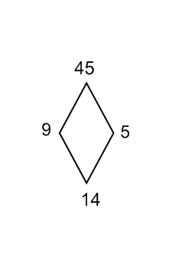
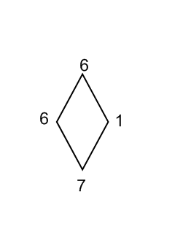
1. Factor the following expressions.
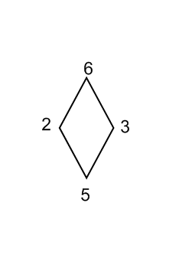
a) $2x^{2}+5x+3$ b) $2x^{2}+7x+3$ c) $3x^{2}+14x+15$

d) $3a^{2}+a-2$ e) $4x^{2}+13x+3$ f) $5x^{2}-23x-10$

2. Factor.
a) $6x^{2}+5x-6$ b) $8y^{2}+2y-3$ c) $9x^{2}-x-10$

3. A rectangular garden has an area of $2a^{2}+3a-5$ m².
a) Write the area as the product of 2 binomials.

b) The garden is to be completely enclosed by a path 1 m wide. Find and simplify and
expression for the area of the path and garden and just area of the path.

4. One factor of $12x^{2}+10x-8$ is
A. $3x+4$
B. $3x-4$
C. $2x+1$
D. $6x-1$

5. The polynomials $4x^{2}+8x-5$ and $12x^{2}-3$ have in common a factor of
A. $4x+1$
B. $4x-1$
C. $2x+1$
D. $2x-1$

6. The factored form of $3x^{2}+19x-14$ is $(x+a)(bx+c)$ where $a, b, and c$ are integers. The value of $b^{c}$, to the nearest hundredth, is ____________.

7. The expression $15x^{2}+11x-56$ can be written in the form $(ax-b)(cx+d)$ where $a, b, c, and d$ are positive integers.
Write the value of a in the first box. Write the value of b in the second box.
Write the value of c in the third box. Wrtie the value of d in the fourth box.

8. When factored, the trinomials $x^{2}-10x+21$ and $x^{2}-4x-21$ have one binomial factor in common. This factor is
A. $x-7$
B. $x+7$
C. $x-3$
D. $x+3$

9. One factor of $-m^{3}-m^{2}+6m$ is
A. $m-2$
B. $m+2$
C. $m-3$
D. $m-6$

10. The expression $x^{2}-4x+c$ cannot be factored if $c$ has the value
A. $-5$
B. $0$
C. $4$
D. $5$

3.10 Factoring Trinomials in the form $ax^{2}+bxy+cy^{2}$
1. Factor.
a) $x^{2}+18xy+45y^{2}$ b) $a^{2}-12ab+36b^{2}$

c) $3b^{2}-15bv-72v^{2}$ d) $4x^{2}-80xy+144y^{2}$

2. Factor.
a) $8x^{2}+22xy+5y^{2}$ b) $6x^{2}+11xy-7y^{2}$

c) $2m^{2}-19mn+9n^{2}$ d) $8x^{2}+7xy-15y^{2}$

3. One factor of $3x^{2}-6xy-9y^{2}$ is
A. $3x$
B. $x+2y$
C. $x+3y$
D. $x+y$
3.11 Factoring Binomials By Difference of Squares
1. Complete the following by determining the missing factor.
a) $x^{2}-36=(x-6)( )$ b) $c^{2}-121=(c+11)( )$

2. Factor the following polynomials if possible (only one is non-factorable).
a) $x^{2}-49$ b) $x^{2}-1$ c) $x^{2}-{15}^{2}$

d) $x^{2}-400$ e) $225a^{2}-b^{2}$ f) $1-25z^{2}$

g) $169z^{2}-4$ h) $49-4h$ i) $49a^{2}-121$

3. The floor of a classroom is rectangular with an area of $81m^{2}-4n^{2}$ square metres.
a) Write expressions in $m$ and $n$ for the length and width of the floor.

b) If the perimeter of the floor is 72 metres, form an equation in $m$ and $n$ and solve for $m.$

4. Factor.
a) $8x^{2}-32$ b) $7x^{2}-7y^{2}$ c) $8-50p^{2}q^{2}$

d) $20a^{2}b^{2}-5a^{4}b^{4}$ e) $x^{4}-1$

f) $3x^{3}-27x$ g) $16x^{4}-81y^{4}$

5. One factor of $16-4m^{2}$
A. $4-m$
B. $8-2m$
C. $4+m$
D. $2+m$

6. Given that $x^{2}-y^{2}=45$ and $x+y=9$ the value of $x$ is
A. 2
B. 5
C. 7
D. Impossible to determine

7. $3x+2y$ is a factor of the binomial $a^{2}x^{2}-b^{2}y^{2}.$ The value of $a^{2}+b^{2}$ is ______.

Factoring Practice
Use one or more strategies to factor the following polynomials.
**GCF, Grouping, Difference of Squares, Diamond Method**
There are two polynomials that are not factorable.
- x² + 5x -6  - x² + 6x + 9  - x² – 36  - x² + 4  - x³ + 2x² + 3x + 6  - x²+ 9x | - 8a² + 7ab – 15b²  - x² – 11x – 12  - 16x² – 25  - 8a² – 4a – 10a + 5  - 25x² – 100  - abx – aby + by – bx
- 4x² – 64  - 4m²n+2mn²  - x³ + 2x² + x + 2  - x² + 3x + 6x + 18 | - x⁴ – 10x² + 25  - 3b² – 15bv – 72v²  - a² – 12ab + 36b²  - x⁴ – 81

Practice Test: Factoring Polynomial Expressions
1. One factor of $9x^{4}-6x^{3}+3x^{2}$ is
A. $9x^{4}$
B. $3x^{2}-2x$
C. $3x^{2}-6x+3$
D. $3x^{2}-2x+1$

2 . When fully factored, the expression $x^{3}y^{2}-x^{2}y^{3}$ is written
- $xy^{2}(x-xy)$
- $x^{2}y(xy-y)$
- $x^{2}y^{2}(x-y)$
- $x^{3}y^{2}(1-xy)$
3. When the greatest common factor is removed from the binomial $75x-50x^{2}$, the binomial can be written in the form $ax(b+cx)$. The value of $a-b-c$ is _______.

4. The expression $3ab^{2}-6a^{3}b+3ab$, when fully factored, is written
A. $ab(3b-2a^{2}+3)$
B. $3a(b^{2}-2a^{2}b+b)$
C. $3ab(b-2a^{2})$
D. none of these
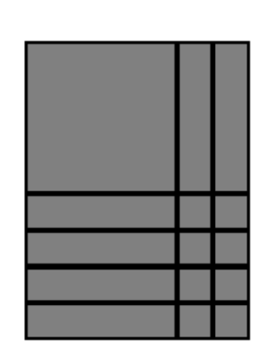
5. The algebra tile diagram represents the factored form
A. $(x^{2}+2x)(x^{2}+4x)$
B. $8(x+2)(x+4)$
C. $(x+2)(x+4)$
D. $(x+1)(x+8)$

6. One factor of $a^{2}-10a-24$ is
A. $a-2$
B. $a-4$
C. $a-6$
D. $a-12$

Use the following information to answer the next question.
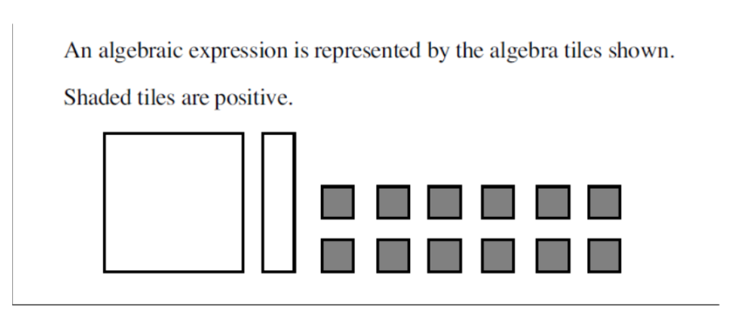

7. The factored form of the algebraic expression represented by the algebra tiles is
A. $(3-x)(4+x)$
B. $(3-x)(4-x)$
C. $\left(4-x\right)\left(3+x\right)$
D. $12-x-x^{2}$

Use the following information to answer the next question.
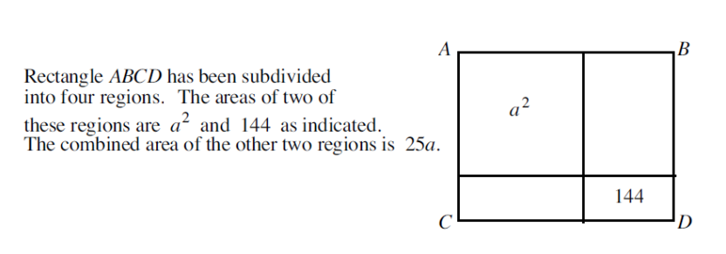

8. The perimeter of rectangle ABCD is
A. $a^{2}+25a+144$
B. $4a+48$
C. $4a+50$
D. Unable to determine from the given information.

9. For which of the following polynomials is $b+3$ not a factor?
A. $b^{2}+3b$
B. $b^{3}-9b$
C. $b^{2}+2b-15$
D. $b^{2}-6b-27$

10. The expression $x^{2}+px+20$ cannot be factored over the integers if $p$ has the value
A. $-9$
B. $-12$
C. $21$
D. $20$

11. The largest value of $w$ for which $x^{2}-wx+48$ can be factored over the integers is _____.

12. One factor of $7a^{2}-28a^{4}$ is
A. $1-2a$
B. $28a^{4}$
C. $1-4a$
D. $1-a$

13. Which of the following is a factor of $6y^{2}-y-1$?
A. $6y-1$
B. $4y-1$
C. $3y-1$
D. $2y-1$

14. The expression $2x^{2}-10x-3x+c$ can be factored by grouping into the product of two binomials. If one of these binomials is $x-5$, then the value of $c$ is ________.

In each of questions #15 – 17 four responses are given.
Answer A if response 1 and 2 only are correct.
B if response 1 and 3 only are correct.
C if response 2 and response 4 only are correct.
D if no response or some other combination of response(s) is/are correct.

15. Which of the following are factors of $2t^{2}-7t-15$?
Response 1: $2t-3$
Response 2: $t-5$
Response 3: $t+5$
Response 4: $2t+3$

16. $x^{2}+25y^{2}$ has a factor of
Response 1: $x-5y$
Response 2: $x-5$
Response 3: $x+5y$
Response 4: $x+y$

17. The trinomial $ax^{2}-12x+c$ can be factored over the integers if
Response 1: $a=1 and c=36$
Response 2: $a=36 and c=1$
Response 3: $a+1 and c=-36$
Response 4: $a=36 and c=-1$

18. When fully factored, the expression $16a^{4}-1$ is written
A. ${\left(4a^{2}-1\right)}^{2}$
B. ${(2a-1)}^{2}{(2a+1)}^{2}$
C. $(4a^{2}-1)(4a^{2}+1)$
D. $(2a-1)(2a+1)(4a^{2}+1)$

19. Three algebraic expressions have been partially factored.
$2x^{2}-3x-14=(2x-7)(x+A)$
$x^{4}-7x^{2}-18=(x^{2}+2)(x-B)(x+B)$
$5x^{2}-40x+80=C{(x-D)}^{2}$

Write the value of A in the first box.
Write the value of B in the second box.
Write the value of C in the third box.
Write the value of D in the fourth box.

Practice Booklet Answer Key
3.1
1.a) Binomial b) Monomial c) Trinomial 2. A) Yes b) No, negative exponent c) Yes d) No, negative exponent e) Yes f) No, exponent is not a whole number

3.
Polynomial Expression | # of Variables | # of Terms | Name of  Polynomial
$$2y^{3}+y^{4}-y+13$$ | 1 | 4 | polynomial
$$25$$ | None | 1 | monomial
$$\frac{3}{5}x^{3}yz^{5}+3x^{2}yz^{4}$$ | 3 | 2 | binomial
Polynomial Expression | Leading  Coefficient | Constant  Term | Name of  Polynomial
$$y^{4}-y+13$$ | 1 | 13 | Trinomial
$$0.2t^{3}-0.3t^{2}+0.4t-0.5$$ | 0.2 | -0.5 | Polynomial
$$\sqrt{5}-x^{6}$$ | -1 | $$\sqrt{5}$$ | Binomial
$$πx^{2}-7-3x$$ | $$π$$ | -7 | Trinomial
$$\frac{-1}{10}c^{2}$$ | $$\frac{-1}{10}$$ | 0 | monomial
4.

5.a) $2w^{3}+6w^{2}-9w+5$ b) $-\frac{2}{3}a^{3}+\frac{1}{4}a^{2}-a-1$ c) $-{4z}^{6}+z^{3}+z-3$
6. a) True b) False c) True d) False e) False f) True 7. a) $-2x+1$ b) $2x^{2}-x+3$ c) $-x-2$ 8. a) ${2x}^{2}-3x-6$ b) $2x^{2}-1$ 9a) $4p-10q$ b) $2x+15$ c) $11y+8z-4x-6$
10. a) $2a-16b-c$ b) $2x^{2}-5x+4$ 11. $2m+n cm$ $12. C$ $13. a$

3.2
1. a) $3\left(2x+1\right)=6x+3$ b) $-3x\left(-x+2\right)=3x^{2}-6x$ 2a) $2x\left(x-2\right)=2x^{2}-4x$ b) $x\left(x+1\right)=x^{2}+x$
3a) $42x-18$ b) $8xy+32xz$ c) $-2ab+2ac-10ad$
d) $-8x^{3}-4x^{2}+24x$ e) $3x+8$ f) $-6x+10$ 4a) $6x^{2}+3xy$ b) $x^{5}-2x^{3}+7x^{2}$
c) $2x-2$ d) $-26$ e) $4a+4b$ 5. $7x^{2}+18x$ 6. C 7. 1

3.3
1a) $\left(x+1\right)\left(x+1\right)=x^{2}+2x+1$ b) $\left(3x+1\right)\left(-x+1\right)=-3x^{2}+2x+1$ 2a) $x^{2}+4x-12$ b) $18d^{2}-57d+45$ c) $8x^{2}-2xy-y^{2}$3.a) 483 b) 7396 4a) $x^{2}+11x+28$ b) $3a^{2}+16a-35$ c) $8a^{2}+30ab+27b^{2} d) 10y^{7}-15y^{5}+2y^{2}-3$ 5. $2a^{2}+13a+20 {cm}^{2}$ $6.a) 21x^{2}+29x-10$ b) $9b^{2}+6b+1$ 7. 273 8. 4

3.4
1a) $x^{2}-16x+64$ b) $x^{2}-81$ c) $-25x^{4}+81$ d) $24x^{2}-50x+24$ e) $2x^{2}+32$
2. a) $y^{3}-3y^{2}-6y-20$ b) $x^{3}-10x^{2}+27x-12$ c) $3x^{3}+14x^{2}+21x+10$
d) $30x^{3}+22x^{2}-36x-16$ 3. $4x^{3}-8x^{2}-11x-3$
3.5
1. a) a = 1, b = 9, c = –12, area = 15.36 units² b) a = 5, b = 7, c = –2, area = 43.6 units²
2. b) $7x^{2}+2x-1$m² 3. a) $3x^{3}+10x^{2}-11x+2$cm² b) $83.875$cm²
4a) $27x^{3}-54x^{2}+36x-8$mm³ b) $64$00cm³

3.1 – 3.5 Practice Test
1. b 2. 13 3. C 4. B 5. D 6. D 7. 1610 8. B 9. 42
10. C 11. A 12. C 13. A 14. B 15. 191

3.6
1a) $12$ b) $p$ c) $2cd$ d) 3y e) $(a+5)$ f) $\left(2p-q\right)$
g) $(3+2y)$ h) $(4mn^{2}-3n-1)$
2. a) $6(m+n)$ b) $7(xy^{2}+7)$ c) $3x(2x-3)$ d) $24y^{2}(2-3y^{3})$
3. a) $4(3x-2y+4z)$ b) $5x(x-2y-4z)$ c) $7a^{2}b^{2}(2+3a-5b)$
4. a) $3x(x+2)$ b) $2xy(3x^{2}+3xy-2y^{2})$ c) $7x(x^{2}-2x+2)$
5a) $691.15 {cm}^{2}$ b) $A=2πr(r+h)$ 6. D 7. D 8. 11 9. 19

3.7
1.a) $(x+5)(3x-7)$ b) $(2-3p)(4-7p)$ 2a) $(x+2)(x+6)$ b) $(x+3)(x+15)$
c) $(a-9)(a-5)$ d) $(t+7)(t-3)$ e) $(x+1)(2x+3)$ f) $(m+3)(3m+5)$
g) $(2a-1)(a-3)$ h) $(a+x)(a+y)$ 3. C 4. B 5. 0
3.8
1a) 2, 3 b) 7, 1 c) 6, 5 d) $-6, -5$ e) 1, 10 f) -3, -5 g) $-7, -8$ h) $-4, -14$
2a) $(x+1)(x+2)$ b) $(x+3)(x+6)$ c) $(x-7)(x-3)$ d) $not factorable$ e) $(y+3)(y+14)$
f) $(x+20)(x+4)$ g) $(d+15)(d+3)$ h) $(n-6)(n-17)$
3.a) $(x+12)(x+3)$ b) 15 m by 6 m
4.a) $2(x+1)(x+2)$ b) $-2(a+6)(a+9)$ c) $-10a^{2}(a-4)(a-6)$ 5. C 6. C 7. D 8. 33

3.9
1. a) $(2x+3)(x+1)$ b) $(2x+1)(x+3)$ c) $(3x+5)(x+3)$ d) $(3a-2)(a+1)$
e) $(4x+1)(x+3)$ e) $(5x+2)(x-5)$ 2. a) $(2x+3)(3x-2)$ b) $(2y-1)(4y+3)$
c) $(9x-10)(x+1)$ 3.a) $\left(2a+5\right)\left(a-1\right)$ b) New dimensions: $2a+7$ by $a+1$ area of rectangle = 2a²+9a+7 m², area of path = 6a+12 m²
4. A 5. D 6. $0.11$ 7. 5837 8. A 9. A 10. D

3.10
1.a) $(x+15y)(x+3y)$ b) $\left(a-6b\right)\left(a-6b\right)or {(a-6b)}^{2}$ c) $3(b-8v)(b+3v)$
d) $4\left(x-18y\right)\left(x-2y\right)$ 2.a) $\left(2x+5y\right)\left(4x+y\right)$ b) $\left(2x-y\right)\left(3x+7y\right)$ c) $\left(2m-n\right)\left(m-9n\right)$
d) $(8x+15y)(x-y)$ 3. D

3.11
1a) $(x-6)(x+6)$ b) $(c+11)(c-11)$ 2. a) $(x-7)(x+7)$ b) $(x+1)(x-1)$
c) $\left(x-15\right)(x+15)$ d) $(x-20)(x+20)$ e) $(15a-b)(15a+b)$ f) $(1-5z)(1+5z)$
g) $(13z-2)(13z+2)$ h) $not factorable$ i) $(7a-11)(7a+11)$
3. a) length = $9m+2n$width = $9m-2n$ b) $m=2$
4. a) $8(x-2)(x+2)$ b) $7(x-y)(x+y)$ c) $2(2-5pq)(2+5pq)$
d) $5a^{2}b^{2}(2-ab)(2+ab)$ e) $(x^{2}+1)(x-1)(x+1)$ f) $3x(x-3)(x+3)$
g) $(4x^{2}+9y^{2})(2x-3y)(2x+3y)$ 5. D 6. C 7. 13

Factoring Practice
1. (x-1)(x+6) 2. (x+3)² 3. (x-6)(x+6) 4. Non-Factorable
5. (x²+3)(x+2) 6. x(x+9) 7. (8a +15b)(a-b) 8. (x-12)(x+1)
9. (4x-5)(4x+5) 10. (4a-5)(2a-1) 11. 25(x-2)(x+2) 12. b(a-1)(x-y)
13. 4(x-4)(x+4) 14. 2mn(2m+n) 15. (x²+1)(x+2) 16. (x+3)(x+6)
17. (x²-5)(x²-5) 18. 3(b -8v)(b +3v) 19. (a-6b)² 20. (x²+9)(x-3)(x+3)
Practice Test: Factoring Polynomials Expressions
1. D 2. C 3. 24 4. D 5. C 6. D 7. A 8. C
9. C 10. D 11. 49 12. A 13. D 14. 15 15. C 16. D
17. A 18. D 19. 2354

