**Math 30 – 2 Logical Reasoning Review**

Choose the best answer for all multiple choice questions. Place numeric response answers on the numeric response answer sheet. Always begin your answers on the left, and leave empty spaces on the right.

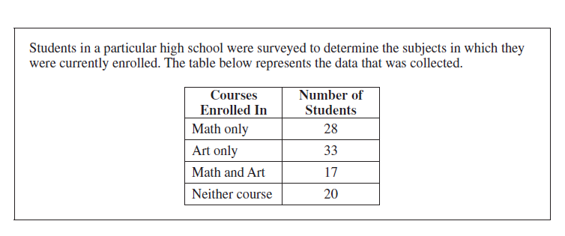

***Use this information to answer the next 4 questions.***

# 



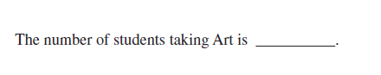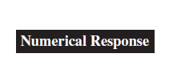

**1.**



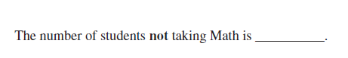

**2.**

1. The number of students taking math or art is
2. 17
3. 61
4. 78
5. 98
6. The set {S} is the set of all multiples of seven, less than 30. Which of the following is **not** a subset of S?
7. {0, 7}
8. {28}
9. {21, 28}
10. {7, 14, 21}

***Use this information to answer the next 3 questions.***

In the universal set {U}, the sets {R} and {T} are disjoint. Set {S} is a subset of {T} and set {P} is a subset of {R}.

1. Which of the following examples **could** be sets R and T?
2. R = {1, 4, 6, 8}, T = {1, 3, 5, 7}
3. R = {even numbers}, T = {multiples of 4}
4. R = { 2, 6, 8, 10}, T = {0, 4, 9, 12}
5. R = {even numbers}, T = {0}
6. “Sets S and P are disjoint.” The truth value of this statement is:
7. True
8. False
9. It is impossible to know without seeing the elements of T and P.



**3.**

If there are 4 elements in set R, then the maximum number of elements in set P is ____.

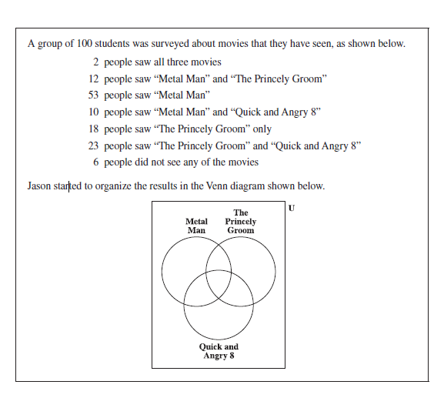***Use this information to answer the next 3 questions.***

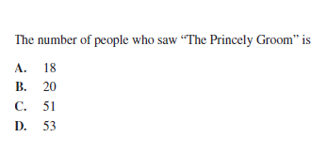



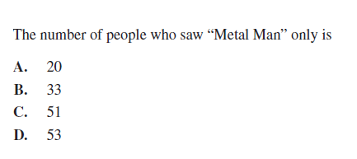

2. 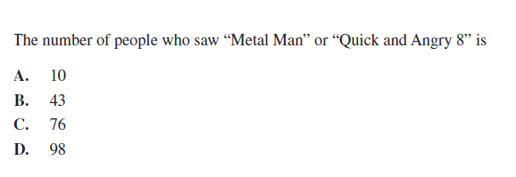



***Use this information to answer the next 3 questions.***

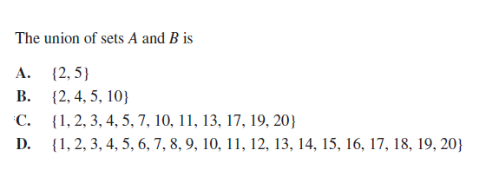

2. 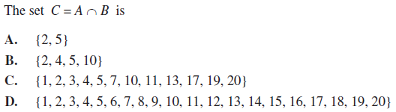
3. “For sets A & B, *n(AUB) = n(A) +n(B)*” This statement is:
4. True
5. False
6. 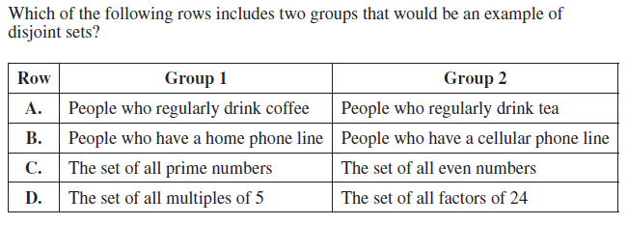

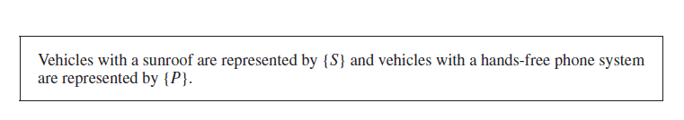

***Use this information to answer the next 3 questions.***

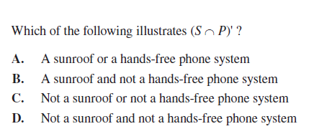

2. Which of the following represents the vehicles which have no sunroof but do have a hands-free phone system?
3. P
4. S’
5. S’∩P
6. S’UP



***Use this information to answer the next 3 questions.***

1. 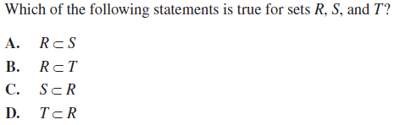
2. 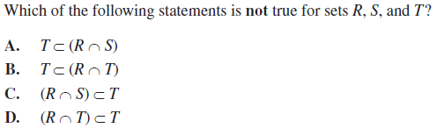



**4.**

Give *n(R) = _______ .*

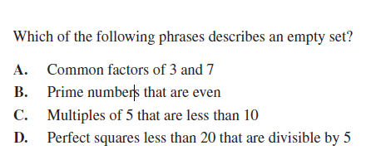



Numeric Response – Answer Sheet

Begin each answer on the left. Leave empty boxes on the right. Decimal points get their own box. Decimal points may not go in the first box.

1.

2.

3.

4.

Written Response

Complete each part of all questions. Show or explain all work.

1. Grade 12 students at a high school were required to take at least one of physics, chemistry or biology.

* 37 took physics
* 62 took chemistry
* 68 took biology
* 27 took physics and chemistry
* 15 took physics and biology
* 33 took chemistry and biology
* 12 students took all three sciences

How many students were in grade 12 that year?

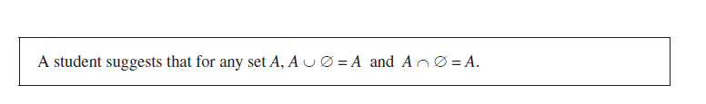***Use this information to answer the next question.***

1. Is the student correct or incorrect? Use an example or a visual representation in your explanation.
2. On an exam, one student wrote ∅ = {0}. Is the student correct? Explain your reasoning.

***Use this information to answer the next 2 questions. Sets are labelled with capital letters, while elements are lower case letters.***

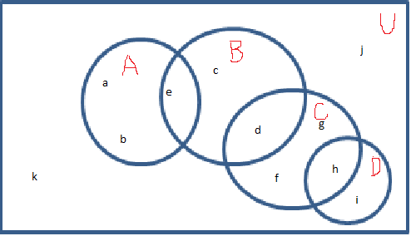

1. Use the diagram above to list the elements of each set.
2. A =
3. AC =
4. D∩C’ =
5. (B∩A) D=
6. (BC)’∩D’=
7. (A∩B)∩C=
8. List two sets from the diagram that are disjoint. _______________________________
9. Shade in D (AB) on the diagram.
10. There is another set F. We know that F⊂C and F ⊂D. Draw and label a circle on the diagram to represent set F.