Unit 4: Relations and Functions Practice Booklet
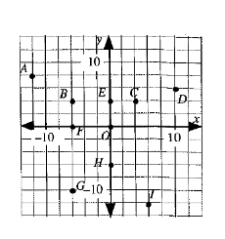
4.1 Review and Preview
1. The following questions refer to the grid on the right.
a) Name the points represented by the following coordinates.
i) $(-6, 4)$ ii) $(6, -12)$ iii) $(0, 4)$

b) List the coordinates of each point.
i) C ii) G iii) F iv) O v) H

c) Which points are in
i) Quadrant I ii) Quadrant II

iii) Quadrant III iv) Quadrant IV

d) Which points are not in a quadrant?

e) Which points have the same x-coordinate? f) Which points have the same y-coordinate?
What visual check can be used? What visual check can be used?

2. Which of the following variables are discrete?
a) temperature b) weight c) altitude d) number of goals

3. Which of the following variables are continuous?
a) number of correct answers on a test b) number of letters in the alphabet
c) number of grams of sugar in a pear d) number of students in a class.

4. Consider the following variables:
i) the age of a truck ii) the weight of a truck
iii) the number of wheels on a truck iv) the number of litres of gas in the gas tank of a truck

Which of the variables above is/are continuous?
- ii) only b) i) and ii) c) i), ii), and iv) d) some other combo of i), ii), iii), iv)

5. On a Cartesian plain, the line segment joining the points $(-3, -2)$ and $(5, -5)$
a) intersects both the x-axis and y-axis
b) intersects the y-axis by not the x-axis
c) intersects the x-axis by not the y-axis
d) does not intersect the x-axis or the y-axis

6. The relationship between degrees Celsius, C, and degrees Fahrenheit, F, is described by the equation
$C=\frac{5}{9}(F-32)$. The ignition temperature of paper is ${451}^{o}$F. To the nearest degree, the ignition temperature of paper in degrees Celsius is __________.

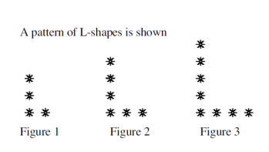

7. Use the following information to answer the next question.
- Complete the table relating the number of stars,
S, to the figure number, N.

- Represent the data from the table of values on the grid.

Figure Number, N | 1 | 2 | 3 | 4 | 5
Number of Stars, S
- Describe in words the relationship between the
number of stars and the figure number.

- Write an equation that can be used to determine number of
stars, if we know the figure number.

- Use the equation to determine the number of stars in figure 43.

- Use the equation to determine the figure number, If there are 140 stars.

4.2 Relationships Between Two Quantities

- Complete the following.
- The mathematical relationship between two quantities is called a _______________.
- The variable used for inputs in a relation is known as the _______________ variable.
- The variable used for outputs in a relation is known as the _______________ variable.
- In the equation $A=πr^{2}$, the independent variable is _______, and the dependent is _____.

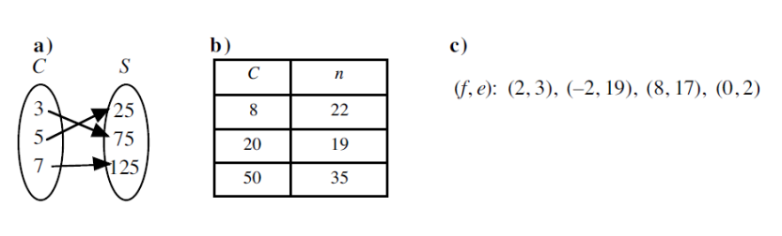
- The diagrams show relations expressed in different ways. In each case list the inputs and outputs:

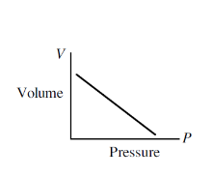
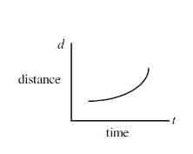
- For each of the following relations, state the independent variable and dependent variable
a) $V=\frac{4}{3}πr^{3}$ b) $C=\frac{5}{9}(F-32)$ c) d)

- A truck’s value, v, depends on its age, a.

- The cost, C, of producing business cards is dependent on the number of cards, n, produced.

- Which of the following statements is false?
- The dependent variable is represented on the vertical axis of a Cartesian Plane.
- The independent variable is represented by the first coordinate of an ordered pair.
- The outputs of a relation are shown on the horizontal axis of a Cartesian Plane.
- The independent variable is usually shown on the right side of an equation.

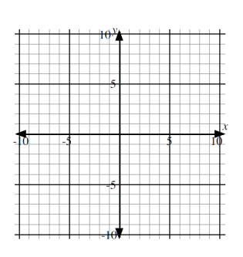
- Consider the relation described by the equation $y=-x-2.$
- Identify the independent and dependent variables.
- Complete the following table of values.
Input $(x)$ | Output $(y)$ | Ordered Pair $(x, y)$
-3
-1
0
1

- Plot the ordered pairs in b) on the grid provided.
- Connect the points and extend the line in both directions.
- Use the graph to determine the value of $y$ when $x=5$.

- Use the equation to determine the value of $y$when $x=5$
and verify, the answer found in e).

- Use the graph to determine the value of $x$ when $y=4$.

- Use the graph to determine the value of $x$ when $y=0$.

- Verify the answer in h) using the equation.

- Is this a linear or a nonlinear relation?

- Consider the relation described by the equation $y={1.5}^{x-2}$. If the input is 4, then the output is _____.

4.3 Domain and Range
1. State the domain and range of each relation.
a) $(2, 3)$, $(0, 2)$, $(4, 8)$, $(-1, 8)$, $(-3, 1)$ b) $(-3, 3)$, $(0, -5)$, $(-3, 3)$, $(5, -2)$, $(-8, 1)$

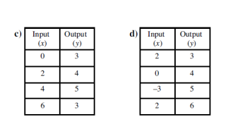
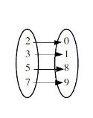

e)

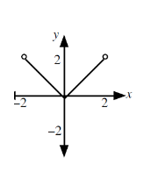
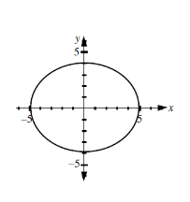
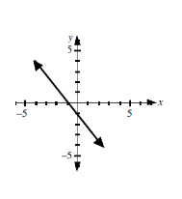

f) g) h)

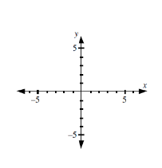
2. In each case draw a graph on the domain of real numbers which could represent a linear relation with
a) one x-intercept b) no x-intercept c) an infinite number of x-intercepts

3. In each case draw a graph of a non-linear relation with
a) domain $x∈R$, range $y≥-3, y∈R$ b) domain $x∈R$, range $y≥-3, y∈R$
two x-intercepts and one y-intercept one x-intercept and one y-intercept

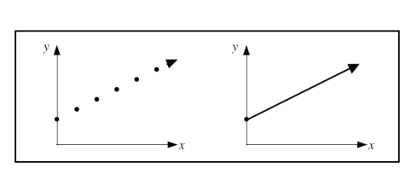
4. The graphs of two relations are shown. Which of the following statements is true?

- The domains are the same, but the ranges are different.
- The ranges are the same, but the domains are different.
- The domains are the same, and the ranges are the same.
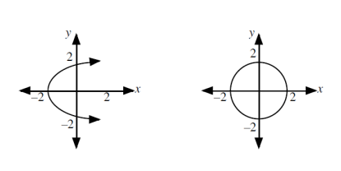
- The domains are different, and the ranges are different.

5. The graphs of two relations are shown. Which of the statements are true?
- The range of each relation is $-2≤y≤2.$
- The range of each relation is $y∈R$.
- The domain of each relation is $-2≤x≤2$.
- None of the above.

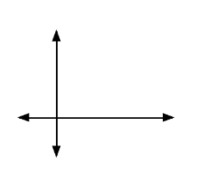
4.4 Graphing a Relation
1. Consider the equation $y=-3x+36$
a) Use a graphing calculator to sketch the graph on the grid provided.
Write an appropriate window so the x and y intercepts are visible.

b) Use a graphing calculator to determine the value of y when $x=5.$

c) Algebraically, verify the answer in b).

d) Use a graphing calculator to determine the value of $x$ when $y=12.$

2. Given the x-coordinate of each relation, determine the corresponding y-coordinate using the graphing feature of a calculator.
a) $y=8x-5$, $x=7$, $y=$ b) $y=0.75x+8$, $x=15$, $y=$

c) $y=x^{2}+3x-12$, $x=-5$, $y=$ d) $y=2x^{3}+15$, $x=2$, $y=$

3. Given the y-coordinate of each relation, determine the corresponding x-coordinate using the graphing features of a calculator. Write your answer to the nearest hundredth where necessary.
a) $y=7x-3$, $x= , y=8$ b) $y=-2x+12, x= y=15$

c) $y=x^{2}+2x-15$, $x= and ,y=3$ d) $y=2x^{3}+15$, $x= , y=10$

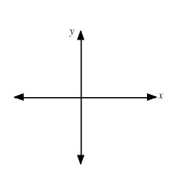
4. Consider the relation given by the equation $y=-0.5x^{2}+8$.
a) Use the table set and table features to complete the table. b) Sketch the graph.
Input $(x)$ | Output $(y)$
-6
-4
-2
0
2
4
c) State the window setting: $x:\left[ , , \right] y:\left[ , , \right]$

d) Determine the value of $y$ when $x=10$

e) Determine the value of $x$ when $y=3.5$

5. For each equation use a graphing calculator to:
- sketch the graph on the grid provided
- list in the chart provided any $x-$ and $y-$intercepts as exact values
- write the coordinates of the points representing the $x-$ and $y-$intercepts on the graph of the relation
a) $y=-3-x$ b) $y=-3x-1$ c) $y=2x-5$
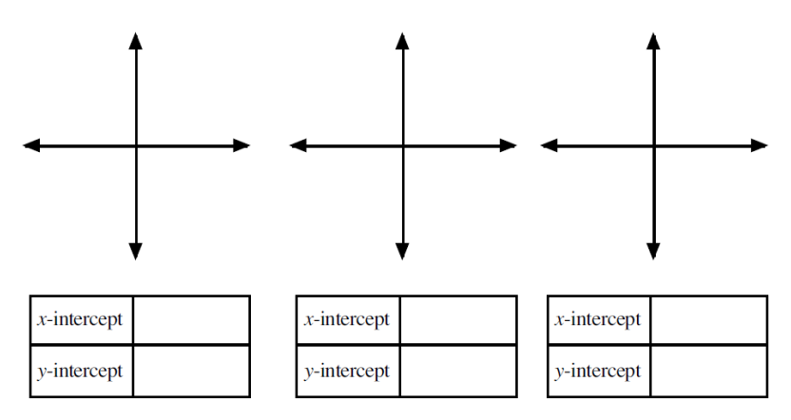
4.5 Interpreting Relations Using a Graphing Calculator
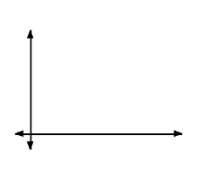
- Students at a senior high school produce an art literary magazine. The cost for this magazine can be modelled by the formula $C=2n+30$, where $C$ is the total cost of the magazine in dollars and $n$ is the number of magazines produced.
- Sketch the graph on the grid provided. Explain why
the graph is not a continuous straight line.

- Is the n-intercept relevant to the graph of this relation.

- What would be the cost for 30 magazines?

- How many magazines are produced if the total cost is $126?

- Describe the significance of the C-intercept

- The height of a soccer ball after a free kick for the Hawks is given by the equation $h=0.03(-d^{2}+40d)$, where$h$ is the height in metres and $d$ is the horizontal distance in metres the ball travels.
- Sketch the graph on the grid.

- What is the height that the soccer ball is kicked from?

- What is the maximum height the soccer ball reaches?

- How far down the field is the ball when it reaches it maximum height?

- Before the ball strikes the ground, a defender heads the ball after it has travelled 38 m. What is the height of the ball above the ground when the defender heads it?

- How high is the ball when it is 3 metres down the field?

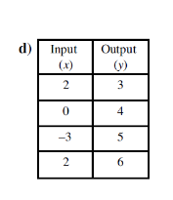
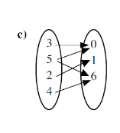
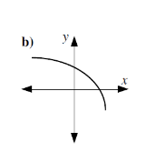
4.6 Functions
1. Determine which of the following relations are functions.
a) $\left(-1, 3\right), \left(-2, 1\right), \left(5, 2\right), \left(7, 3\right)$

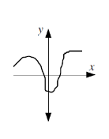
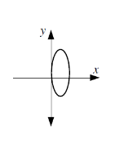

e) $\left(0, 0\right), \left(1, 2\right), \left(2, 3\right), \left(3, 4\right), (4, 3)$ f) g)

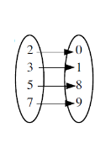

h)

Elements of Domain | 3 | 2 | 1 | 0 | -1 | -2 | -3
Elements of Range | 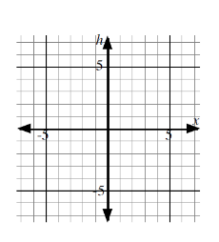
2. Consider the function $f\left(x\right)=x^{2}-4$
a) Complete the following table of values.

b) Plot the ordered pairs on the Cartesian plane.

c) Draw a smooth curve through the points.

3. The domain of the function $h\left(x\right)=6$ is {0, 10, 20}
- List the ordered pairs of the graph of the function.

- Show the function $h$ in a Cartesian graph.

4. The function $f\left(x\right)=6-2x$ has domain $\{0, 2, 4, 6, 8\}$.
Which of the following is not an element of the range of the function?
- -10
- 2
- 4
- -6

5. Which of the following statements is not always true for a function?
a) A function is a set of ordered pairs $(x, y)$ in which for every $x$ there is only one $y.$
b) A vertical line must not intersect the graph of a function in more than one point.
c) For every output there is only one input.
d) For every element of the domain, there is only one element in the range.

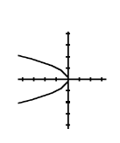
6. Which of the following represents a function?
1. “multiply the number by 3 and add 5” 2. $y=-x^{2}$

3. $\left(9, 3\right), \left(4, 2\right), \left(1, 1\right), \left(0, 0\right), \left(1, -1\right), \left(4, -2\right)$ 4.

- 1 only
- 1 and 2 only
- 1 and 3 only
- Some other combination of 1 – 4

4.7 Function Notation
- If $f\left(x\right)=x^{3}-2x^{2}-x-5$, evaluate:
- $f(5)$ b) $f(-3)$

- Consider the function $f$ defined by $f\left(x\right)=8-2x$, $x∈R$. Determine:
- $f(4)$ b) an expression for $f(2t)$ c) an expression for $f(a+3)$

- If $f\left(x\right)=3x^{2}-2x-9$, determine a simplified expression for
- $f(-x)$ b) $f(x-5)$

- a) If $f\left(x\right)=5x-7$, then determine the value of $x$ if $f\left(x\right)=43$

- If $g\left(t\right)=56-3t$, then determine the value of $t$ if $g\left(t\right)=11$.

- If $P\left(x\right)=50-3x^{2}$, then determine the values of $x$ if $P\left(x\right)=-25$

- Consider the function $f$ defined by $f\left(x\right)=6x-15$. Find:
- $f(0)$ b) an expression for $f(2x+1)$ c) the solution to the equation $f\left(x\right)=27$

- The graph of a function $f$ is shown.
- Complete:
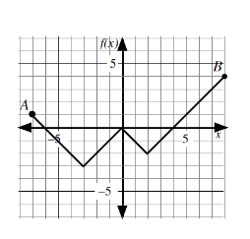
i) $f\left(3\right)=$ ii) $f(-3)$ iii) $f\left(-6\right)=$

- Write the ordered pairs associated with i) , ii), and iii).
i) ii) iii)

- State the values of $x$ if:
i) $f\left(x\right)=3$ ii) $f\left(x\right)=-2$ iii) $f\left(x\right)=-4$

- Write the $x-$ and $y-$intercepts of the graph using function notation.

- Complete the following statements.
- The domain of $f$ is $\left\{x\right|____≤x≤_____,x∈R\}$
- The range of $f$is $\left\{f\left(x\right)\right|____≤f(x)≤_____,f(x)∈R\}$

- A special type of weather balloon follows a path which can be represented by the formula
$h\left(t\right)=-9t^{2}+900t$, where $h(t)$ is the height in cm after $t$ minutes.
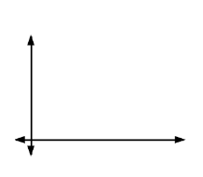
- Sketch the graph of the function on the grid.

- Determine the value of $h(30)$ and $h(70)$.

- What is the highest point the balloon will reach? (in metres)

- When will the balloon land?

- Suggest an appropriate domain and range for the function $h(t)$.

Relations and Functions Practice Test
- Which of the following variables is discrete?
- The time taken to run 50 metres.
- The distance travelled in a train.
- The number of animals in a zoo.
- The weight of a dog.

- Which of the following statements is false?
- The domain of a relation is associated with values of the independent variable.
- The dependent variable is represented by the first coordinate of an ordered pair.
- The inputs of a relation are shown on the horizontal axis of a Cartesian Plane.
- The range of a relation is represented on the vertical axis of the graph of the relation.

- To the nearest hundredth, the positive x-intercept on the graph of the relation $2x^{2}+6y^{2}=7$is ____.

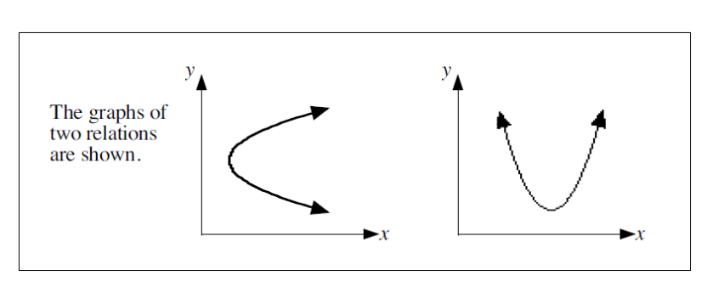
Use the following information to answer the next question.

- Which of the following statements is true?
- The domains are the same, but the ranges are different.
- The ranges are the same, but the domains are different.
- The domains are the same, and the ranges are the same.
- The domains are different, and the ranges are different.

- The graph of the relation $4x^{2}-3y=12$ has $x$-intercepts $a$ and $b$, and $y-$intercept $c$. The value of the product $abc$ is ________.

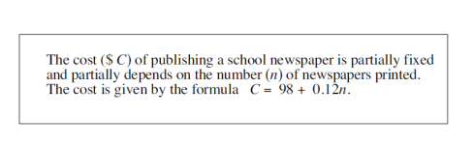
Use the following information to answer the next two questions.

- The cost of publishing 780 newspapers is
- $191.60
- $773.76
- $94.58
- $9 458.00

- The domain of the relation can be expressed in the form $n≥x$, and the range can be expressed in the form $C≥y.$ Write the value of $y$ in the first two boxes, and the value of $x$ in the last two boxes.

- The function $f\left(x\right)=3-2x^{2}$, has domain $\{-6, -4, 0, 2, 5\}$.
Which of the following is an element of the range of the function?
- 35
- 27
- 1
- -29
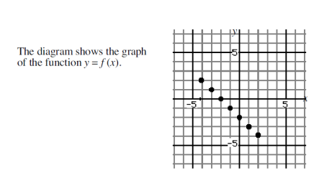
Use the following information to answer the next question.

- The diagram shows the graph of the function $y=f(x)$.
The value of $f(-2)$ + $f(2)$ is
- -4
- -2
- 0
- $f(0)$

Use the following information to answer the next two questions.

Consider the function $P\left(x\right)=5x+2$

- The value of $P(6)$ is
- $\frac{8}{5}$
- $\frac{4}{5}$
- 32
- 58

- If $P\left(b\right)=6$, then $b=$
- $\frac{8}{5}$
- $\frac{4}{5}$
- $\frac{5}{4}$
- 32

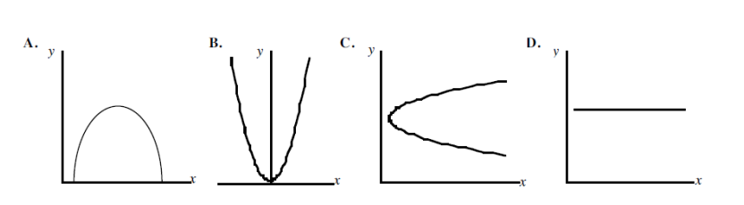
- Which of the following diagrams shows a relation which is not a function?

- Consider the graph of the function $f\left(x\right)=4x-10$. The $x-$intercept of the graph of $f$is
- $-10$
- $-2.5$
- $2.5$
- $10$

- Given a function $g\left(x\right)=px+q$ with $g\left(0\right)=2$ and $g\left(1\right)=3$, then
- $p=1$, $q=0$
- $p=3$, $q=2$
- $p=1, q=2$
- $p=3, q=0$

- If $f\left(x\right)=3^{x}$and $f\left(-a\right)=\frac{1}{81}$, then $a=$
- $4$
- $-4$
- $\frac{-1}{4}$
- $\frac{1}{4}$

- If $g\left(x\right)=\frac{2}{3}x+6$, an expression for $g(2x-1)$ is
- $\frac{4}{3}x+5$
- $\frac{4}{3}x+\frac{16}{3}$
- $\frac{4}{3}x+11$
- $\frac{8}{3}x+5$

- Consider the following functions:
- $p\left(x\right)=x^{2}-4x-2$ 2. $p\left(x\right)=\frac{1}{3}x+14$ 3. $p\left(x\right)=3x^{2}+x$ 4. $p\left(x\right)=7-5x$
For each function evaluate $p(-3)$, and put the expressions in order from greatest to least. The order is
- 4312
- 3412
- 3124
- None of the above

- If $f\left(x\right)=1-2x-5x^{2}$, and if $f(x+2)$ is written in the form $ax^{2}+bx+c,$the value of $a-b-c$ is ____.

- $f\left(a\right)=\frac{a}{a+4}.$The exact value of $f\left(5\right)-f(5^{-1})$ written as a rational number in simplest form is $\frac{p}{q}$. The value of $p$ is ______.

- Which of the following cannot be used to represent a function?
- Graph
- Table of Values
- Ordered Pairs
- Coordinate

Answer Key
4.1
1.a) i) B ii) I iii) E
b)i) $(4, 4)$ ii) $(-6, -10)$ iii) $(-6, 0)$ iv) $(0, 0)$ v) $(0, -6)$
c) i) C, D ii) A, B iii) G iv) I d) E, F, H, O
e) E, O, H and B, F, G they are on the same vertical line
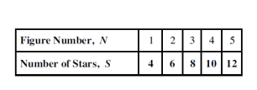
f) B, E, C and F, O they are on the same horizontal line
2. D 3. C 4.C 5. B 6. 233
7. a) c) The number of stars is two more than twice the figure number
d) $S=2n+2$ e) 88 stars f) 69

4.2
1a) relation b) independent c) dependent d) r, A
2. a) in: C out:S b) in: C out: n c) in: f out: e
3. a) ind: r dep: V b) ind: F dep: C c) ind: time dep: distance d) ind: pressure dep: volume
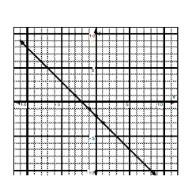
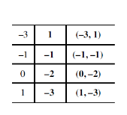
e) ind: a dep: v f) ind: n dep: C
4. C
5. a) ind: x dep: y b) c) e) y = -7 f) y = -7
g) x = -6 h) x = -2
6. 2.25 j) linear

4.3
1.a) domain: $\{-3, -1, 0, 2, 4\}$ range: $\{1, 2, 3, 8\}$ b) domain: $\left\{-8, -3, 0, 5\right\}$ range: {-5, -2, 1, 3}
c) domain: $\{0, 2, 4, 6\}$ range: $\{3, 4, 5\}$ d) domain: $\{-3, 0, 2\}$ range: $\{3, 4, 5, 6\}$
e) domain $\left\{2, 3, 5, 7\right\}$ range: $\{0, 1, 8, 9\}$ f) domain: $\{x|x∈R\}$ range: $\{y|y∈R\}$
g) domain $\{x|-5≤x≤5, x∈R\}$ range: $\{y|-4≤y≤4, y∈R\}$
h) domain: $\{x|-2<x<2,x∈R\}$ range: $\{y|0≤y<2, y∈R\}$
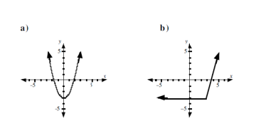
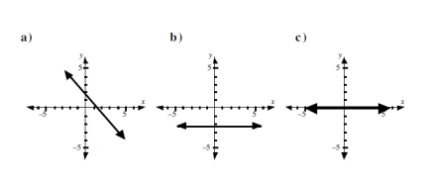
2. 3.

4. D 5. D
4.4
1. a) x:[-5, 20, 5] y:[-20, 50, 10] b) $y=21$ c) 21 d) $x=8$
2.a) $y=51$ b) $y=19.25$ c) $y=-2$ d) $y=31$
3. a) $x=1.57$ b) $x=-1.5$ c) $x=-5.36$ and $x=3.36$ d) $x=-1.36$
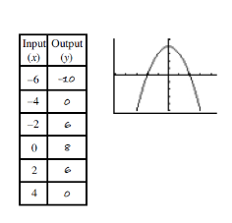
4. a) b) c) $x:\left[-10, 10, 2\right] Y:[-10, 10, 2]$ d) $-42$ e) $-3, 3$
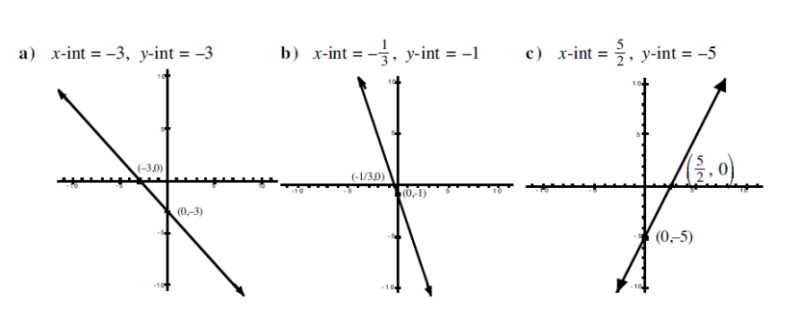
5.

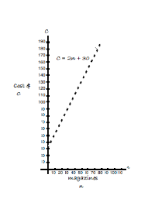

4.5
1. a) b) No since the number of magazines cannot be negative.
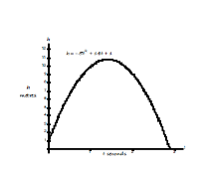
c) $90 d) 48 e) Represents the fixed charge of $30 regardless of the
number of magazines sold.

2. a) b) 0 metres c) 12 metres
d) 20 metres e) 2.28 metres f) 3.33 metres

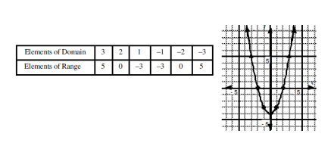
4.6
1. a) yes b) Yes c) No d) No e) Yes f) No g) No h) Yes

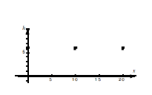
2. 3. a) (0, 6), (10, 6), (20, 6)

b)

4. C 5. C 6. B

4.7
1. a) 65 b) -47 2. a) 0 b) $f\left(2t\right)=8-4t$ c) $f\left(a+3\right)=2-2a$
3. a) $f\left(-x\right)=3x^{2}+2x-9$ b) $f\left(x-5\right)=3x^{2}-32x+76$ 4. a) 10 b) 15 c) $±5$
5. a) -15 b) $12x-9$ c) $x=7$
6. a) i) -1 ii) -3 iii) 0 b) i) (3, -1) ii) (-3, -3) iii) (-6, 0) c) i) 7 ii) -4, -2, 2 iii) no solution
d) $f\left(-6\right)=0$ $f\left(0\right)=0$ $f\left(4\right)=0$ e) domain: -7, 8 range: -3, 4
7. b) $h\left(30\right)=18900$ $h\left(70\right)=18900$ c) 22500 cm or 225 m d) 100 minutes after take off
e) domain: $\{t|0≤t≤100, t∈R\}$ range: $\{h(t)|0≤h(t)≤22500, h(t)∈R\}$

Practice Test
- C 2. B 3. 1.87 4. D 5. 12 6. A 7. 9800 8. D 9. A 10. C 11. B
12. C 13. C 14. C 15. A 16. B 17. B 18. 40 19. 32 20. D

