Unit 5: Linear Relations Practice Booklet
5.1 Line Segments on a Cartesian Plane
1. Determine the length of each line segment. **A rough sketch may aid your understanding.
a) $A\left(2, 7\right)$ to $B(5, 7)$ b) $E\left(2, -8\right)$ to $F\left(2, 3\right)$

c) $I(-3, -8)$ to $J(-3, -3)$ d) $M(-325, -892)$ to $N(255, -892)$

e) $A(p, q)$ to $B(p-4, q)$ f) $C\left(m-3, n+5\right)$ to $D(m-3, n+12)$

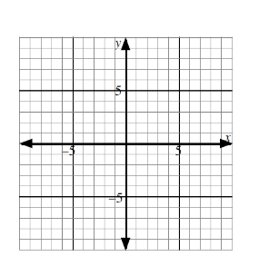

2. A triangle has vertices $P(-4, -3)$, $Q(9, -3)$, and $R(1, 5)$.
Sketch the triangle on the grid.
Determine the area of the triangle.

3. Use the Pythagorean Theorem to determine the lengths of the following line segments shown on the grid.
Give each answer as
- A mixed radical in simplest form.
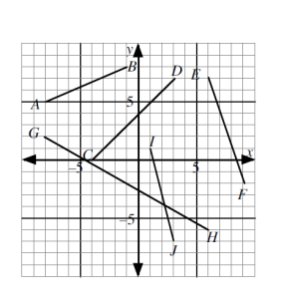
- A decimal to the nearest hundredth.

- AB

- EF

5.2 Slope of a Line Segment
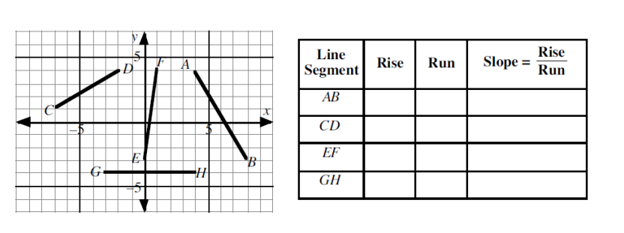
1. Each line segment on the grid has endpoints with integer coordinates. Complete the table.

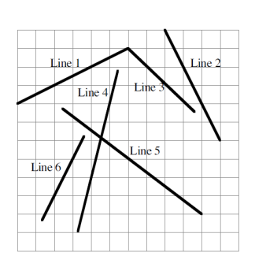
2. Each of the lines on the grid passes through at least two points with integer coordinates.
Calculate the slope of :

Line 4:

Line 5:

Line 6:

3. Draw a line segment on the grid which passes through the point $(-5, -2)$ and has a slope of $\frac{2}{3}$. The line segment must be long enough to cross both the x-axis and the y-axis.
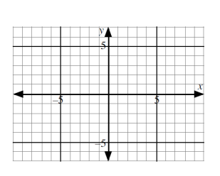
Write the coordinates of three other points on the line segment which have integer coordinates.

4. Repeat question #3 for a line segment with slope $-\frac{4}{3}$ which passes through the point $(-9, 6)$.

5. Two of the three measures are given for rise, run, and slope. Calculate the value of the third measure in each of the following.
a) slope $=\frac{5}{7}$ and run $=49$ b) slope $= \frac{-6}{11}$ and run $=33$ c) slope $= \frac{3}{4}$ and rise $=15$

6. A ramp which has been set up by skateboarders has a slope of $\frac{2}{3}$. Calculate the height of the ramp if the ramp has a base length of 1.5 metres.

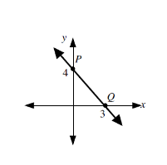
7. The slope of $\overline{PQ}$is
A. $\frac{3}{4}$
B. $\frac{-3}{4}$
C. $\frac{4}{3}$
D. $\frac{-4}{3}$

8. The point $(-4, 0)$ is on a line which has a slope of $\frac{-2}{5}$. The next point with integers coordinates on the line to the right of $(-4, 0)$ is
A. $(-9, -2)$
B. $(-9, 2)$
C. $(1, -2)$
D. $(-2, -5)$

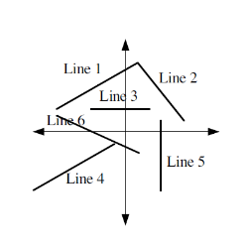

5.3 The Slope Formula
1. State whether the slope of each line is
positive, negative, zero or undefined.
Line 1:

Line 2:

Line 3:

Line 4:

Line 5:

Line 6:

2. Use the slope formula to calculate the slope of the line segment with the given endpoints.
a) $A(12, -2)$ and $B(0, 3)$ b) $U(-172, -56)$ and $V(-172, -56)$ c) $D(-3, -8)$ and $F(1, 5)$

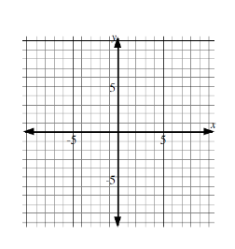
3. The line segment joining each pair of points has the given slope. Determine each value of $k$ and draw the line segment on the grid.
a) $S(4, 6)$ and $T(5, k)$ slope $=3$ b) $L(k, -2)$ and $M(3, -7)$ slope $=\frac{-1}{2}$

4. Consider points $P\left(4, -9\right), Q\left(-1, -7\right), and R(-11, -3)$.
Use the slope formula to prove that the points $P, Q, and R$ are collinear.

5. Consider points $A\left(8, -7\right), B\left(-8, -3\right), and C(-24, 1)$.
a) Are the points $A, B, and C$ collinear?

b) Does the point $D(-2, -4)$ lie on the line segment AC? Explain.

6. The slope of the line segment joining $E(5, -1)$ and $F(3, 7)$, is
A. $-3$
B. $-4$
C. $-\frac{1}{3}$
D. $-\frac{1}{4}$

7. If the line segment joining $(2, 3)$ and $(8, k)$ has slope $-\frac{2}{3}$, then $k=$
A. $-1$
B. $-3$
C. $-6$
D. $7$

5.4 Parallel and Perpendicular Lines
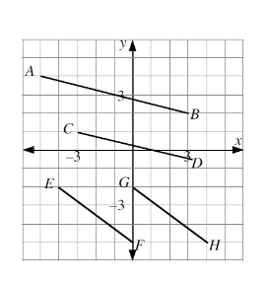
1. a)Determine the slope of the following pairs of line segments using $m=\frac{rise}{run}$.
$m_{AB}=$

$$m_{CD}=$$

$$m_{EF}=$$

$$m_{GH}=$$

b) Do you notice any patterns?

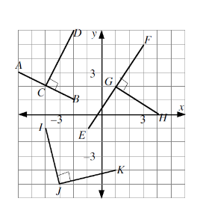

2. a) Determine the slope of the following pairs of
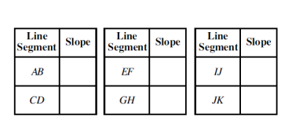
perpendicular line segments using$m=\frac{rise}{run}$.

- Multiply the slope of the pairs of perpendicular line segments.
$m_{AB}×m_{CD}$ $m_{EF}×m_{GH}$ $m_{IJ}×m_{JK}$

3. The slopes of two line segments are given. Determine if the lines are parallel, perpendicular, or neither.
a) $m_{AB}=\frac{8}{20}, m_{PQ}=\frac{2}{5}$ b) $m_{AB}=\frac{1}{6}, m_{PQ}=\frac{2}{12}$ c) $m_{AB}=\frac{7}{8}, m_{PQ}=\frac{8}{7}$

d) $m_{AB}=\frac{9}{3}, m_{PQ}=\frac{-1}{3}$ e) $m_{AB}=\frac{4}{8}, m_{PQ}=2$ f) $m_{AB}=\frac{-5}{2}, m_{PQ}=\frac{-2}{5}$

4. The slopes of some line segments are given.
$m_{AB}=6$ $m_{CD}=\frac{1}{6}$ $m_{EF}=-6$ $m_{GH}=6$ $m_{IJ}=-6$ $m_{KL}=\frac{1}{6}$
Which pairs of lines are parallel to each other?

5. The slopes of some line segments are given.
$m_{AB}=-2$ $m_{CD}=\frac{1}{4}$ $m_{EF}=0.5$ $m_{GH}=2$ $m_{IJ}=-4$ $m_{KL}=\frac{-1}{2}$ $m_{MN}=4$ $m_{OP}=-\frac{1}{4}$
Which pairs of lines are perpendicular to each other?

6. $∆ABC$ has vertices $A\left(3, 5\right), B\left(-2, -5\right), C\left(-5, 1\right).$
a) Explain how we can determine if $∆ABC$ is a right triangle.

b) Determine if $∆ABC$ is a right triangle.

7. The line segment joining $U(-3, p)$ and $V(-6, 5)$ is perpendicular to the line segment joining $X(4, 2)$ and $Y(9,0)$. The value of $p$, to the nearest tenth, is ___________.

Linear Relations Practice Test 5.1-5.4
- Which of the following horizontal or vertical line segments has the greatest length?
- PQ with $P(2, 9)$ and $Q(7, 9)$
- RS with $R\left(4, 11\right)$ and $S(4, 4)$
- TV with $T(-6, 1)$ and $V(2, 1)$
- WZ with $W(-5, -5)$ and $Z(-5, -11)$

- The exact distance between the points $\left(8, 3\right)and \left(5, -2\right)$ is
- $5.83$
- $\sqrt{34}$
- $8$
- $34$

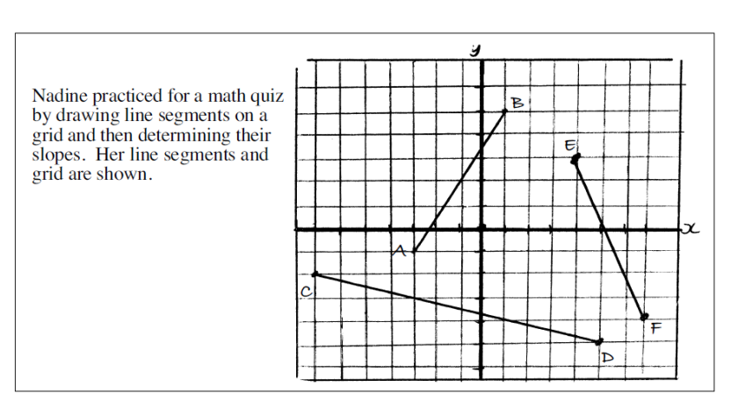
Use the following information to answer questions 3-5

**Matching Match each line segment on the left with the slope on the right. Each slope may be used once, more than once, or not at all.

Line Segment Slope
- AB A. $-4$ B. $-\frac{3}{2}$

- CD C. $-\frac{7}{3}$ D. $\frac{3}{7}$

- EF E. $\frac{3}{2}$ F. $-\frac{1}{4}$

Use the following information to answer the next two questions
Line Segment AB Line Segment $PQ$
$A\left(-2, 4\right) B(2, -6)$ $P\left(7, 1\right) Q(-3, -3)$

- Which of the following statements is correct about the line segments?
- The length of line segment $AB$ is greater than the length of line segment $PQ.$
- The length of line segment $AB$ is less than the length of the line segment $PQ.$
- The length of line segment $AB$ is equal to the length of the line segment $PQ.$
- Not enough information is given to calculate the lengths of the line segments.

- Which of the following is correct about the line segments?
- The slope of line AB is positive and the slope of line segment PQ is negative.
- The slope of line AB is positive and the slope of line segment PQ is positive.
- Line segment AB is parallel to line segment PQ.
- Line segment AB is perpendicular to line segment PQ.

- K and L are the points $\left(4, 7\right)and (-1, -3)$ respectively. The slope of a line perpendicular to KL is
- $\frac{1}{2}$
- $-\frac{1}{2}$
- $2$
- $-2$

- Two lines have slope of $-\frac{2}{3}$ and $\frac{15}{t}$ respectively. If the lines are perpendicular, then the value of t must be _______.

- The line segment joining $K(-1, y)$ and $L(-2, 8)$ is parallel to the line segment joining $M\left(4, 4\right)$ and $N(0, 5)$. The value of $y$, to the nearest hundredth, is _______.

5.5 Slope Y-Intercept Form
1. Each equation represents a relation.
a) $y=6x+1$ b) $y=x^{2}$ c) $3x^{4}+5$ d) $y=\frac{-1}{4}x-8$

e) $y=1-x$ f) $y=\frac{2}{1-x}$ g) $y=4x$ h) $y=4^{x}$

Without graphing, place the letters a) through h) in the appropriate row below.

LINEAR:

NONLINEAR:

2. State the slope and y-intercept of the graph of each linear equation.
a) $y=7x-2$ b) $y=\frac{4}{3}x+3$ c) $y=6-\frac{1}{6}x$ d) $4y=6x+8$ e) $y=ax+b$

3. Write the equation of each line with the given slope and y-intercept.
a) slope $=4$ b) slope $=\frac{1}{5}$ c) slope $-3$ d) slope $=m$
y-intercept $=-9$ y-intercept $=\frac{1}{2}$ y-intercept $=0$ y-intercept $=b$

4. For each line, state the slope and the y-intercept. Graph the equation without using a graphing calculator.
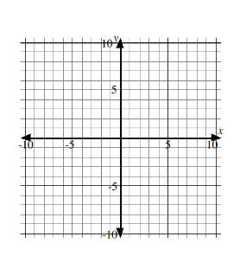
a) $y=\frac{1}{4}x+2$ b) $y=-\frac{4}{3}x$ c) $y=5$ d) $y=-x-4$

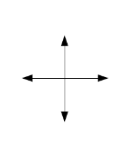
5. Use a graphing calculator to sketch the graph of each of the following linear equations. Complete the table giving the x-intercept to the nearest hundredth.
a) $y=7x-8$ b) $y=75-\frac{5}{3}x$
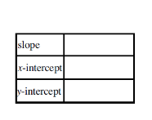

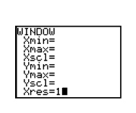

6. Which of the following does not represent the equation of a straight line?
A. $y=3x$
B. $y=11-3x$
C. $y=\frac{x}{3}$
D. All of the above represent the equation of a straight line.

7. Which of the following statements is false for the line $y=-\frac{1}{2}x+1$?
A. The graph of the line falls from the left to right.
B. The x-intercept is $2$.
C. The graph passes through the point $(8, -3)$.
D. The line is perpendicular to the line $y=-2x+4$

5.6 Writing Equations in the Form $y=mx+b$
1. Write the equation of each line.
a) with slope $4$and y-intercept $-6$ b) passing through the origin with a slope of $-\frac{3}{5}$

c) with a y-intercept of $-9$ and perpendicular d) through the point $(0, 1)$ and perpendicular to
to $y=-\frac{2}{3}x+7$ $y=4x-2$

e) with the same y-intercept as $y=2x-3$ and perpendicular to $y=\frac{7}{3}x-2$

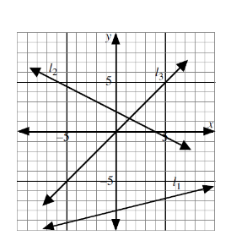
2. Each of the lines on the grid passes through
points with integer coordinates.
**Determine the equation of each line in the form $y=mx+b.$

Line 1:

Line 2:

Line 3:

3. State the equation of the following lines: **a sketch may be useful
a) through the point $\left(-5, 3\right)$ and parallel to the y-axis

b) through the point $(-5, 3)$ and parallel to the x-axis

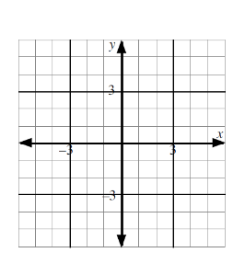

4. Consider the graph of the function with the equation $y=2$.
a) State the values of $m$ and $b$.

- Sketch the graph on the grid provided.

- State the x and y-intercepts of the graph.

- Determine the domain and range of the function.

5. A line is parallel to the x-axis and passes through the point $(-6, 10)$. The equation of the line is
A. $x=10$
B. $x=-6$
C. $y=10$
D. $y=-6$

6. The line through the origin, perpendicular to the line with equation $y=\frac{2}{3}x$, has equation
A. $y=\frac{2}{3}x$
B. $y=\frac{3}{2}x$
C. $y=-\frac{2}{3}x$
D. $y=-\frac{3}{2}x$

7. The point $(2, -1)$ lies on the line with slope $3$. The y-intercept of the line is
A. $-7$
B. $-5$
C. $5$
D. $7$

8. Consider the line which is perpendicular to the line $y=\frac{1}{3}x+4$ and has the same y-intercept as $y=6x-7$. If the equation of this line is written in the form $y=mx+b$, then the exact value of $m-b$ is ___.

9. Two perpendicular lines intersect on the y-axis. One line has equation $y=4x+6$. If the equation of the other line is $y=mx+b,$then the exact value of $m+b$ is ____.

5.7 General Form
1. Convert the following equations from slope y-intercept form $(y=mx+b)$ to
general form $(Ax+By+C=0)$, where $A, B, and C$ are integers.
- $y=7x-3$ b) $y=-\frac{3}{4}x+5$ c) $y=\frac{2}{3}x+\frac{1}{6}$

2. Determine the slope and y-intercept of the graph of the following lines.
a) $x+y-11=0$ b) $3x+6y-7=0$ c) $8y=4x+32$

3. Determine the slope, y-intercept, and x-intercept of the graph of the following lines.
a) $2x+y-6=0$ b) $4x-5y-3=0$

4. Write the equation, in general form, of a line parallel to $2x-3y+9=0$ and with the same y-intercept as
$22x-3y-18=0$

5. Match each equation on the left with the correct characteristic of the graph of the equation on the right. Each characteristic may be used once, more than once, or not at all.
Equation Characteristics

- $6x-2y+5=0$ A. Slope $=-\frac{1}{3}$

- $2x-5y=0$ B. y-intercept $=-\frac{5}{2}$

- $x+3y+6=0$ C. Passes through $(-10, -4)$

- $x-4y+10=0$ D. Slope $=0$

- $2x-y-5=0$ E. y-intercept $=\frac{5}{2}$

F. Perpendicular to $y=\frac{5}{2}x-3$

G. x-intercept $=\frac{5}{2}$
6. The slope of the line with equation $6x+5y-1=0$
A. $-\frac{6}{5}$
B. $-\frac{5}{6}$
C. $\frac{6}{5}$
D. $\frac{1}{5}$
7. Which line has a y-intercept of 1?
A. $x+5y+1=0$
B. $x+3y+3=0$
C. $x-2y+2=0$
D. $2y=3x+1$

8. The slope of a line perpendicular to the line $x+3y+8=0$ is
A. $-8$
B. $-\frac{1}{3}$
C. $\frac{1}{3}$
D. $3$

5.8 Point –Slope Form
1. State the equation, in slope-point form, of the line through the given point and with the given slope.
a) $\left(9, 3\right), 4$ b) $\left(8, -2\right), -3$ c) $\left(-7, 0\right), \frac{1}{4}$

2. Write the following equations in slope y-intercept form $y=mx+b$.
a) $y+1=8(x-2)$ b) $y+3=7(x+12)$

3. Find the equation, in slope y-intercept form, of the line through the given point and with the given slope.
a) $\left(2, 4\right), 6$ b) $\left(-6, 2\right), \frac{1}{2}$

4. Find the equation, in general form, of the line through the given point and with the given slope.
a) $\left(6, 1\right), 3$ b) $\left(-9, -2\right), \frac{2}{5}$

5. The slope-point form of a line is given. State the slope and the coordinates of the point which was used to write the equation.
a) $y-9=-\frac{11}{3}(x+3)$ b) $y+3=\frac{1}{2}x$ c) $y-8=-2(x-6)$ d) $y=\frac{2}{5}x$

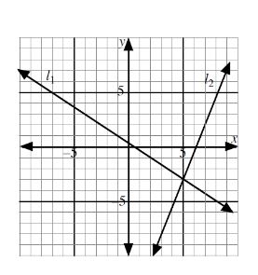
6. Two lines have been drawn on the grid.
Each line passes through at least two points with
integers coordinates.
Determine the equation of each line.

7. The equation of the line passing through the point $(4, 2)$ with slope $-3$ is
A. $3x+y-14=0$
B. $3x+y+10=0$
C. $3x+y-10=0$
D. $3x+y+14=0$

8. The equation of the line passing through the origin with slope $-\frac{1}{2}$ is
A. $x+2y=0$
B. $x-2y=0$
C. $2x+y=0$
D. $2x-y=0$

Linear Relations Practice Test 5.5-5.8
- The slope of the line with equation $3y=2x-12$ is
  - $2$
  - $\frac{2}{3}$
  - $-4$
  - $-12$

- The y-intercept of the graph of the line with equation $y=5x-10$ is
  - $2$
  - $5$
  - $10$
  - $-10$

- Which equation represents a line with a slope of $3$ and a y-intercept of $-4$?
  - $y=-4x+3$
  - $y=-\frac{1}{3}x-4$
  - $y=3x-4$
  - $y=3x+4$

- Which of the following is the equation of a line perpendicular to $5y+x+6=0$
  - $y=5x$
  - $y=x$
  - $y=\frac{1}{5}x$
  - $y=-\frac{1}{5}x$

- Which of these ordered pairs can be found on the graph of the line $3x-5y-4=0$
i) $(8, 4)$ ii) $(-3, 1)$ iii) $(0, -0.8)$ iv) $(-2, 2)$
  - i) and ii) only
  - i) and iii) only
  - i), ii), and iii) only
  - some other combination of i), ii), iii), and iv)

- The point of intersection of the line $9x-3y+9=0$ and the y-axis is
  - $(0, 9)$
  - $(0, 3)$
  - $(0, -1)$
  - $(0, -3)$
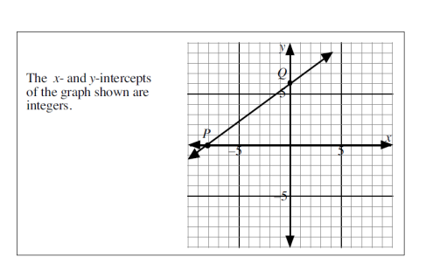
Use the following information to answer the next two questions.

- The equation of line $PQ$ is
  - $3x+4y+24=0$
  - $3x+4y+32=0$
  - $3x-4y+24=0$
  - $3x-4y+32=0$

- Given that the line above passes through $(7.2, k)$, the value of $k$, to the nearest tenth, is ________.

- If the lines $ax+by+c=0$ and $dx+ey+f=0$ are parallel, then
  - $ae-bd=0$
  - $ae+bd=0$
  - $ad-be=0$
  - $ad+be=0$

- Given that the line joining $(2, 3)$ and $(8, -q)$, where $q∈W$, is perpendicular to the line $3x-2y-5=0$, then the value of $q$ is __________.

- The equations of four straight lines are
1) $7x-y=0$ 2) $7x+y-6=0$ 3) $x-7y+4=0$ 4) $x+7y-2=0$
Which pair are perpendicular?
- 1) and 2) only
- 1) and 4) only
- Both 1) and 4) and 2) and 3)
- Both 1) and 2) and 2) and 3)

- The line passing though the points $\left(-5, -2\right)$ and $(-2, -1)$ has equation
  - $x+y+3=0$
  - $x+3y+5=0$
  - $x-3y+1=0$
  - $x-3y-1=0$

- The lines $3x-y+2=0$ and $5x-By+26=0$, where $B∈W,$intersect on the y-axis. The value of $B is ___________.$

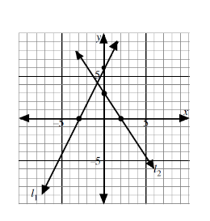
- Which equation represents a line which is
perpendicular to line $l_{i}$ and has the same
x-intercept as line $l_{2}.$
- $x+2y-2=0$
- $x+2y+2=0$
- $2x+y-4=0$
- $2x+y+4=0$

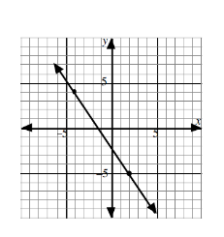

- The equation of the line shown in the
diagram is $Ax+2y+C=0$. The value
of $\frac{A}{C}$, to the nearest hundredth, is ______________.

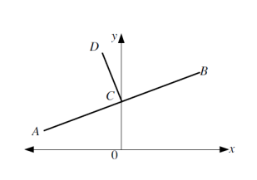
- The equation of $AB$ is $x-2y+4=0$.
$AB$ cuts the y-axis at $C$. $CD$ is perpendicular
to $AB.$
The equation of $CD$ is?
  - $x+2y-2=0$
  - $2x+y-2=0$
  - $2x-y+2=0$
  - $2x+y-4=0$

- Which of the following lines is/are perpendicular to the line $9x+y+2=0$?
i) $9y+x=2$ ii) $9y-x=2$ iii) $y=9x+2$ iv) $9y=x-2$
- i) and iii) only
- ii) only
- iv) only
- Some other combination of i), ii), iii) and iv)

- The line $l_{1}$ passes through the points $\left(-3, 5\right)$ and $(-2, -1)$.
Which of the following statements is/are true?
i) $l_{1}$ passes through $(4, -37)$
ii) $l_{1}$ has an x-intercept of $-\frac{13}{6}$
iii) $l_{1}$ is perpendicular to $y=\frac{1}{6}x+2$
- i) and ii) only
- i) and iii) only
- ii) and iii) only
- i), ii), and iii)

Answer Key
5.1
1.a) 3 b) 11 c) 5 d) 580 e) horizontal 4 f) vertical 7
2. a) 52 units² 3. i)a) $\sqrt{58}$ b) 7.62 ii) a)$3\sqrt{10}$ b) 9.49
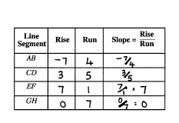
5.2
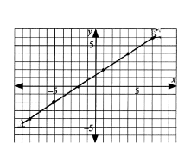
1. 2. Line 4: 4 Line 5: $-\frac{3}{4}$ Line 6: 2
3. $(-8, -4)\left(-2, 0\right), \left(1, 2\right), (4, 4)$

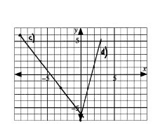
4. Line C $\left(-6, 2\right), \left(-3, -2\right),(0, -6)$ 5. A) rise = 35 b) rise = -18 c) run: 20
6. 1 metre
7. D 8. C

5.3
1. Line 1: Positive 2: negative 3: Zero 4. Positive 5. Undefined 6. Negative
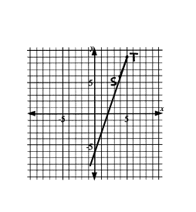
2. a) $\frac{-5}{12}$ b) $Undefined$ c) $\frac{13}{4}$
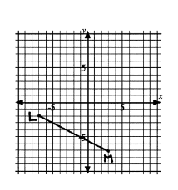
3. a) $k=9$ b) $k=-7$ 4. The slope of PQ and QR are $\frac{-2}{5}$ so they are collinear
5. a) Yes, the slope of AB and BC are both $-\frac{1}{4}$.
b) No, AD has a slope $\frac{-3}{10}$

6. B 7. A

5.4
1.a) $AB=\frac{-1}{4}$ $CD=\frac{-1}{4}$ $EF=\frac{-3}{4}$ $GH=\frac{-3}{4}$
b) The slope of AB=CD and EF=GH because the lines are parallel.
2. a) $AB=-\frac{1}{2}$ $CD=2$ $EF=\frac{3}{2}$, $GH=\frac{-2}{3}$ $IJ=-4$ , $JK=\frac{1}{4}$
b) They all equal -1
3. a) parallel b) parallel c) neither d) perpendicular e) neither f) neither
4. AB and GH EF and IJ CD and KL
5. AB and EF CD and IJ GH and KL MN and OP
6. a) Determine the slope of each side of the triangle. If two of the slopes are negative reciprocals, the triangle is a right triangle.
$b) Yes m_{BC }= -2 and m_{AC}=\frac{1}{2}$
7. 12.5
Practice Test 5.1-5.4
1. C 2. B 3. E 4. F 5.C 6. C 7. D 8. B 9. 10 10. 7.75

5.5
1. Linear: a, d, e, g Non-Linear: b, c, f, h
2. a) $m=7, y_{i}=-2$ b) $m=\frac{4}{3}, y_{i}=3$ c) $m=-\frac{1}{6}, y_{i}=6$ d) $m=\frac{3}{2}, y_{i}=2$ e) $m=a, y_{i}=b$
3. a) $y=4x-9$ b) $y=\frac{1}{5}x+\frac{1}{2}$ c) $y=-3x$ d) $y=mx+b$
4. Graph to check 5.a) $m=7, y_{i}=-8, x_{i}=1.14$ b) $m=-\frac{5}{3}, y_{i}=75, x_{i}=45$
6. D 7. D

5.6
1.a) $y=4x-6$ b) $y=-\frac{3}{5}x$ c) $y=\frac{3}{2}x-9$ d) $y=-\frac{1}{4}x+1$ e) $y=-\frac{3}{7}x-3$
2. Line 1: $y=\frac{1}{4}x-8$ Line 2: $y=-\frac{1}{2}x+2$ Line 3: $y=x$
3a) $x=-5$ b) $y=3$
4.a) $m=0, b=2$ b) Horizontal line going through $y=2$ c) $x_{i}=none, y_{i}=2$
d) domain: $\left\{x|x∈R\right\}$, range: $\left\{y|2\right\}$
5. C 6. D 7. A 8. 4 9. 5.75

5.7
1. a) $7x-y-3=0$ b) $3x+4y-20=0$ c) $4x-6y+1=0$
2. a) $m=-1, y_{i}=11$ b) $m=-\frac{1}{2}, y_{i}=\frac{7}{6}$ c) $m=\frac{1}{2}, y_{i}=4$
3. a) $m=-2, y_{i}=6, x_{i}=3$ b) $m=\frac{4}{5}, y_{i}=\frac{-3}{5}, x_{i}=\frac{3}{4}$
4. $2x-3y-18$ 5.i) E ii) C iii) A iv) E v) G 6. A 7. C 8. D

5.8
1. a) $y-3=4(x-9)$ b) $y+2=-3(x-8)$ c) $y=\frac{1}{4}(x+7)$
2. a) $y=8x-17$ b) $y=7x+81$
3. a) $y=6x-8$ b) $y=\frac{1}{2}x+5$
4. a) $3x-y-17=0$ b) $2x-5y+8=0$
5. a) $m=-\frac{11}{3}, point=(-3, 9)$ b) $m=\frac{1}{2}, point=(0, -3)$ c) $m=-2, point=(6,8)$
d) $m=\frac{2}{5}, point (0,0)$
6. Line 1: $3\left(y-1\right)=-2\left(x+1\right)……. 2x+3y-1=0$
Line 2: $2\left(y+3\right)=5\left(x-5\right)………… 5x-2y-31=0$
7. A 8. A

Practice Test 5.5-5.8
1. B 2. D 3. C 4. A 5. B 6. B 7. C 8. 11.4 9. A 10. 1 11. C 12. D
13. 13 14. A 15. 0.75 16. B 17. D 18.D

