Waves Questions

1. Determine the wavelengths of the following waves by measuring with a ruler. Check your answers by measuring the wavelength at different locations.

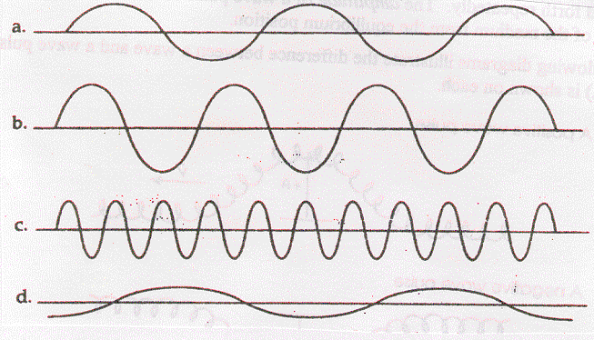

2. Use the following diagram to answer the following questions.
(Scale: 1 small square = 10 cm)
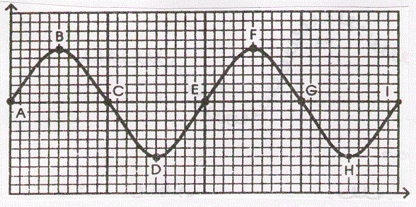

a. Crests occur at which points?
b. Troughs occur at which points?
c. Which point is one wavelength away from point C?
d. Which point is one-half of a wavelength from point B?
e. What is the wavelength?
f. What is the amplitude?
g. If the frequency is equal to 40 Hz, what is the speed of the wave?
3. What is a wave?

4. Draw a transverse wave. Label the wavelength, crest, trough and equilibrium line.

5. Sketch a negative wave pulse of amplitude 2.5 cm. If it is imagined to be travelling from right to left, mark on your diagram the direction of motion of the particles of the medium at the leading and trailing edges of the pulse.

6. What happens to the energy associated with a wave after the wave has been damped out?

7. Sketch a longitudinal wave including wavelength, compressions and rarefactions.

8. For each of the following examples of periodic motion, determine the period and frequency.
a. a metronome clicks 50 times in 15 s
b. a patient breathes 18 times in 30 s
c. a flywheel makes 300 revolutions in one minute
d. a cricket chirps 30 times in 15 s
9. People can actually use their bodies as particles in a medium to form a wave. In each of the diagrams, determine if the wave is transverse or longitudinal and label the appropriate parts.
a. Fans do the wave at a football game.

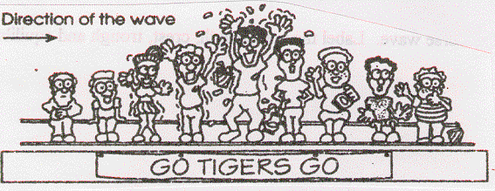

b. People push in the line for football tickets.

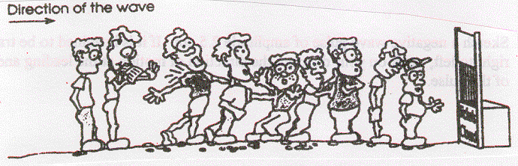
10. Match the following terms to the appropriate phrase:
____ Period a. the motion of a pendulum
____ Frequency b. an S shape on its side
____ Amplitude c. number of vibrations per second
____ Displacement d. the completion of one cycle
____ Sine Curve e. the location of an object
____ Vibration f. time to complete one vibration
____ Simple Harmonic Motion g. position of maximum displacement

11. A meter stick is held vertically behind an object on a spring. The object vibrates from the 20 cm mark to the 32 cm mark on the stick. Find:
a. the equilibrium position
b. the amplitude
c. the displacement when the object is at the 20 cm mark, 24 cm mark, 26 cm mark, and 30 cm mark.

12. The crest of a wave in a ripple tank travels 60 cm in 2.0 s. If the distance between crests is 0.50 cm, what is the frequency of the wave? (60 Hz)

13. The wave generator in a ripple tank produces circular wave patterns at a frequency of 6.0 Hz. A student measures the distance on the floor between troughs of the 3rd and 8th waves to be 7.5 cm. What is the speed of the wave? (9.0 cm/s)

14. Radio telescopes receive waves from distant stars. If such a wave has a wavelength of 21 cm and travels at the speed of light (c = 3.00 x 10⁸ m/s), what is the frequency? (1.43 x 10⁹ Hz)

15. A tuning fork that vibrates at 256 Hz produces a sound wave that is 130 cm long.
a. What is the speed of sound in air? (332.8 m/s)

b. A sound wave in a steel rail has a period of 1.613 x 10⁻³ s and a wavelength of 10.5 m. What is the speed of sound in steel? (6510 m/s)

c. Two men are standing beside a railway line and they are 500 m apart. If one man strikes the rail with a hammer how long does it take for the other man:
i. to see the hammer hit the rail? (1.67 x 10⁻⁶ s)

ii. to hear the sound from the rail line? (7.68 x 10⁻² s)

iii. to hear the sound in the air? (1.50 s)

16. Using the terms frequency, wavelength and speed, fill in the blanks:
__________ and ____________ are determined by properties of the medium, while ____________ is determined by the source of the wave.
17. A wave in a coiled spring travels at 10 cm/s.
a. If the frequency of the wave is 2 Hz, what is the wavelength? (5.0 cm)

b. If the frequency of the wave is doubled to 4 Hz does the wave speed change?

c. What would occur if the frequency were reduced to 1 Hz?

18. The human ear can hear frequencies ranging from 20 Hz to 20000 Hz. If the speed of sound in air is 340 m/s, what is the range of wavelengths for audible sound? (17 m, 0.017 m)

19. If the wavelength of a wave is quadrupled and the speed is quartered, what happens to the frequency? (decreased by 16 times)

20. Would you increase or decrease the frequency of a ripple tank generator to produce a wave with a longer wavelength? Explain.

21. The speed and wavelength of deep water waves are 12 cm/s and 1.5 cm respectively. When the water waves enter a shallow region, their speed is reduced to 8.0 cm/s. What is the wavelength in the shallow region? (1.0 cm)

22. The speed and wavelength of shallow water waves are 12 cm/s and 1.5 cm respectively. When the waves enter a deeper region the wavelength increases to 2.0 cm. What is the speed in the deep region? (16 cm/s)

23. A 12 Hz wave travels from deep to shallow water. As it does so, its speed changes from 20 cm/s to 16 cm/s. What are the wavelengths in each region? (1.67 cm, 1.33 cm)

24. The pulses shown in the following diagrams are moving toward each other. Sketch the shape of the resulting wave pattern at the moment that they directly overlap.

Resonance and Sound Questions

1. The first resonant length of a closed air column occurs when the length is 30 cm. What will the second and third resonant lengths be? (90 cm, 150 cm)

2. The third resonant length of a closed air column is 75 cm. Determine the first and second resonant lengths. (15 cm, 45 cm)

3. What is the shortest closed air column that will resonate at a frequency of 440 Hz when the speed of sound is 352 m/s? (20.0 cm)

4. The second resonant length of an air column open at both ends is 48 cm. Determine the first and third resonant lengths. (24 cm, 72 cm)

5. An organ pipe, open at both ends, resonates at its first resonant length with a frequency of 128 Hz. What is the length of the pipe if the speed of sound is 346 m/s? (1.35 m)

The Doppler Effect Questions

1. You are standing at a railway crossing. A train approaching at 100 km/h sounds its whistle. If the frequency of the whistle is 400 Hz and the speed of sound in air is 344 m/s, what is the frequency you hear (a) when the train approaches you and (b) when the train has passed you? (435 Hz, 370 Hz)

2. A train whistle emits a sound with a wavelength of 38 cm. If the speed of sound is 340 m/s, what frequency will be heard by you if the train is driving at 20 m/s (a) away from you and (b) toward you? (845 Hz, 951 Hz)

3. The whistle on a train has a frequency of 2150 Hz. If the speed of sound is 339 m/s, what is the apparent frequency you would hear if the train was travelling toward you at 25 m/s? (2321 Hz)

4. A distant galaxy is being observed by an astronomer on Earth. The frequency for sodium light is 5.17 x 10¹⁴ Hz. The measured frequency for sodium light from the galaxy is 4.70 x 10¹⁴ Hz. If the speed of light is 3.00 x 10⁸ m/s, what is the speed of the galaxy relative to us? Is it moving toward or away from us? (3.0 x 10⁷ m/s away from Earth)

